Reflexive Control: My Thinking About Your Lieing To My Lies You Think About
by Michael J. McCarron
[rough draft, last version: 9/9/2020]
https://github.com/autonomous019/Artificial-Intelligence-Research

Part 1: Early Reflexive Control Research
In the chapter “Lessons from an American Weapons Developer” we briefly introduced the topic of ‘Reflexive Control’, to quickly jog one’s memory, this is the doctrine created in the 1960s by Soviet military planners to enforce their will on other countries or entities by making others ‘choose’ their positions through coercion, negotiation and manipulation, it was related to the concept of military deception (maskirovka). Deception can be not always obvious, understanding the subtleties of the Russians we should observe the difference between ‘vranyo’ and ‘lozh’:

“...it is important to become familiar with the Russian terms lozh and vranyo,, two of the most common terms of in-exactitude in the language. Lozh refers to actual lies and total untruths, whereas vranyo is a more subtle term referring to the dissemination of untruths which have some grounding in reality.” (Chotikul, 1986, 66)

Indeed, successful RC depends on camouflage and stealth, without which such operations become useless. The starting point of RC is a lie:

...facts will change this predetermined approach, in which the main aim is to create several alternative truths (instead of one truth), which by their very existence can give rise to doubts. Telling ‘tactical truths’ and lack of trust between the government and citizens provides a fertile ground for such activities: nobody expects to hear the objective truth from the official channel as people expect everybody to lie to some extent. The observations made over the past ten years show that Russia has, at least to a certain degree, managed to create such alternative narratives, independently of the objective truth. In the long term, systematic information operations carried out by Russia are also producing results: they create uncertainty and suspicion between citizens and the government. At the same time, efforts are made to steer the opinions of susceptible citizens in polarized societies. (Vasara, 2020, 79)

In a later section we shall review the polarization effect of the Boolean Algebra of RC. It is important to understand that the basis of effective RC is to create confusion in the adversary, to trick the enemy from the beginning.
The Soviet Union’s military was heavily invested in developing RC for military operations. It has also been suggested RC was first begun as a means of domestic influence in the SU:

...there was a need for reflexive control in the Soviet society, which prompted systematic research on ‘soft’ influence operations. This research and the influence operations may first have been directed at the country’s own citizens after which they were incorporated into the planning of military operations and the use of military force (Pynnöniemi, 2018, cf. Peters, 2016, p. 4). (Vasara, 2020, 32)

Deception (maskirovka), becomes an optimized tool of warfare under the Soviets. The reality is these concepts are ancient, simply read some ancient Asian Martial arts texts, though they took on a new calculated and computational nature in the Soviet Union during the Cold War.

“The political counterpart to maskirovka appears to lie in the concept of ‘Finlandization’. Briefly stated, Finlandization describes a process whereby the Soviet Union influences the domestic and foreign policy behavior of non-communist countries in a way that leads them to follow policies congenial to or approved by the Soviet Union,” (Chotikul, 1986, 72)

And of course, as one traces back these notions we can back trace to Nazi doctrines as such originally inculcated by the German Black Reichswehr such as the military doctrine of ‘poisoning’- perverting the intellectual space of your enemy or target group. A Russian military planner explains the use of deception in RC, in particular keying in on the tactic of diversions:

According to Karankevich, success requires a systemic approach in which, parallel to the actual operational plan, a diversion plan is prepared on the basis of which appropriate diversionary moves can be carried out (cf. the model of Kazakov & Kiryushin presented in Chapter 4.6). In that case, the commander must determine in advance which of the enemy’s decisions are advantageous to his own side. Karankevich also discusses the use of information technology, which in his view, is connected with the use of reflexive control. He does not only emphasize the role of deceiving the enemy but also highlights the extreme complexity of carrying out deception operations in today’s situation. In his view, deception lies at the core of information operations and deception measures must be planned at strategic level (Karankevich, 2006, p. 143).

Deception is a high level chain of command decision according to Karankevich. As can be seen the snow ball effect can become a fixture in the calculations of RC with the use of multiple layers of deception or Shannon Entropy. There are clear similarities between Karankevich’s thoughts and Lefebvre’s approach to modelling the information available to the enemy and shaping it in accordance with one’s interests (discussed earlier). (Vasara, 2020, 48-9)
However, as Russian military leaders warn because of the use of deception in the method of RC it can lead to a myopic closed circuit of misinformed facts:

Strict differentiation between methods and the need to find desired reflexions in all actions are additional weaknesses in this approach. This may lead to a situation (which existed during the Cold War) in which the mere possibility of doing something is interpreted as an intention of the other party: a neutral text assumes a different meaning when it is interpreted using the ‘methods’. It is entirely possible that these methods only exist in researchers’ imagination and their determination to find a deeper meaning in all human activities. (Vasara, 2020, 79)

As one could see that deception or camouflage is a source of Shannon Entropy in the equations of RC. In analyzing the effectiveness of RC you first must need to accurately assess the conditions of your target vectors. If you go against an adversary in RC that appears sophomoric in RC capabilities it may turn out to be deception.

Chotikul notes in her report that one of the key findings is that underestimating the enemy and its reflexion capacity may substantially undermine the effectiveness of reflexive control methods. It is also important to understand that a variety of different techniques should be applied, and the same technique should not be used repeatedly. This prevents the enemy from deducing which methods and techniques are used and from developing appropriate countermeasures (Chotikul, 1986, p. 83).

In Russia during the detente between the German Reichswehr and the Soviet Union N. Bernstein was the first to suggest the concept of a reflexive image, which would become essential to Lefebvre’s theories, A Finnish military researcher writes of his contribution to RC:

In 1929, Nikolai Bernstein, a Soviet neurophysiologist, wrote for the first time that when acting in a goal-oriented manner, human brain creates two models: the real world (the model describing what exists around us) and the goal (the model of what will exist around us in the future). Bernstein called the function linking these two models as the feedback arising from the joint impact of neurons and muscles. In 1934, he proposed that the concept ‘reflex arc’, according to which the stimulus-reaction link moves in a single direction should be replaced with the concept ‘reflex circle’, in which the stimulus and reaction also move in the opposite direction (Gerovitch, 2002, p. 109). Identical results were published by Norbert Wiener, one of the founders of cybernetics, 15 years later (Susiluoto, 2006, p. 99). However, Bernstein’s theories were not appreciated as they ran counter to the Pavlovian physiology, and in the Soviet Union, he was marginalised (Gerovitch, 2002, p. 109). (Vasara, 2020, 11)

V. Lefebvre is the seminal reference in the West and to a great extent in his native Russia on Reflexive Control. As a Colonel in the Soviet Army he began his first mathematical formulations of RC, he is especially mentioned in connection to the creation of RC in a Game theoretic framework, with Reflexive Game Theory. He also discovered the science of ‘Fast Reflexion’ which allows one’s subconscious to be over-ridden through the Amygdala via a controlling force. Reflexive Control is a sub-science of Cybernetics, which is the study of control in mechanical and biological systems. Specifically, RC grew out of Soviet Military Cybernetics, hence you see in the West the corollary in private Defense contractors. It is important to realize that RC is a part of cybernetics, and as such covered under cybersecurity threats. The Soviet conception of cybernetics, although as a scientific discipline was refuted as a Western Capitalist conspiracy under Stalin flourished under Kruschev. Lefebvre working as a military engineer in cybernetics first formulated the equations that would come to define RC.
Lockheed Martin engineer Dr. Ed Nozawa, who has studied in Russia RC, points out there are two types of reflexive schools of thought, or rather that RC is a subset of overall Reflexive Processes, of which RC is a subset, Nozawa created automated decision making systems for Lockheed-Martin. American studies dating to at least 1986 have systematically studied Soviet Reflexive Control, Diane Chotikul writing in her thesis for the Naval Postgraduate School notes the dual nature of Reflexive Control:

“In addition to being made up of two components—the psychological and cybernetic—reflexive control theory has other dual aspects. For one, it be conducted in two ways: 1. reflexive control through transformation the enemy's information processing (cognitive), and 2. reflexive control by selecting the messages (informational). Furthermore, reflexive control can be of two types: 1. constructive reflexive control in which the enemy is influenced to voluntarily [consciously or unconsciously] make a decision favorable to the controlling … or 2) destructive reflexive control in which means are employed to destroy, paralyze, or neutralize the procedures and algorithms of the enemy’s decision making processes. These varied aspects and applications of the theory add to its range and potential effectiveness, as well as to the difficulty of discerning it in use. (Chotikul, 1986, 81-2)

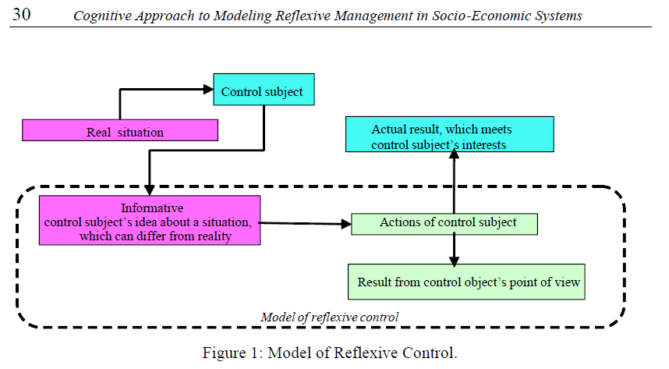
(Shemayev, 2007)

Constructive RC is also sometimes referred to as Creative RC. The mathematics of RC is expressed in Boolean Algebra, usually working with sets. Most RC methodologies incorporate the typical cybersecurity divisions of Red and Blue, Red attacks, Blue defends against attack. The algebra that Lefebvre created is expressed mathematically below, where the calculations become more complex in the case when a subject under control may realize they are being manipulated, even to the point of playing the Reflexive Game to their advantage if they have sufficient knowledge of the situation.
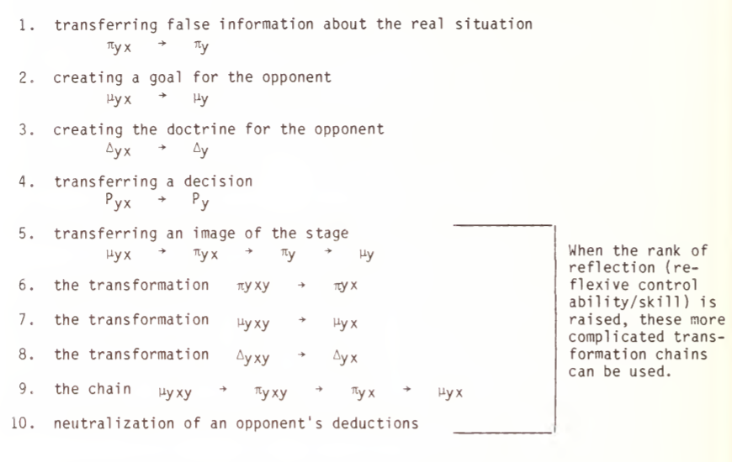
Lefebvre’s equations for Reflexive Control.

Chotikul goes into the history of the development of Lefebvre’s ideals regarding RC:

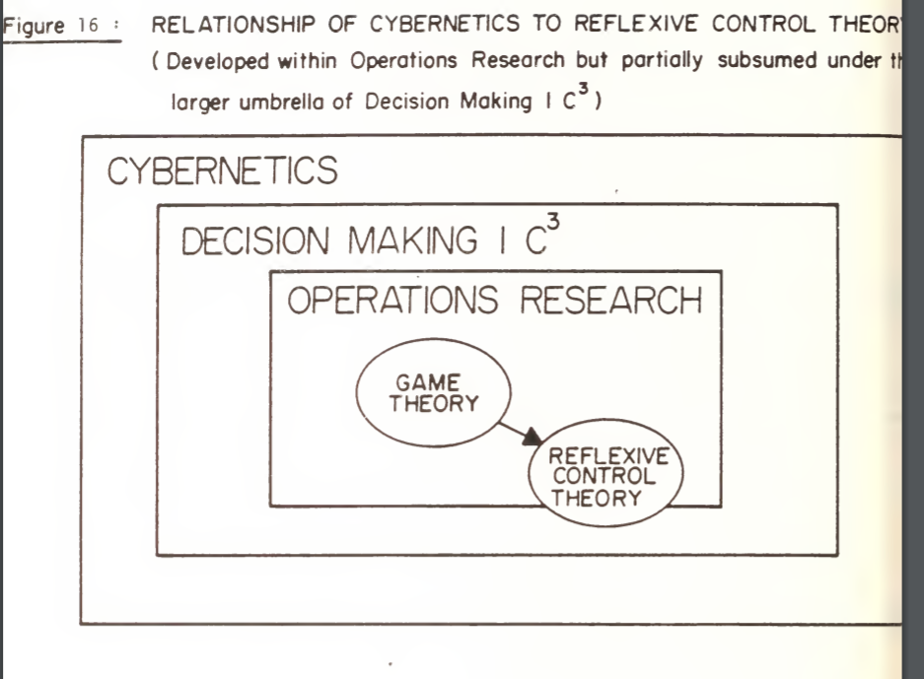

“Cybernetics was initially developed by the Soviets at the First Computer Center of the Ministry of Defense. One of the major tasks of the institute during the early 1960s was to develop methods of optimization of the decision making process. Lefebvre worked in a sub-unit of the institute developing algorithms for the automation of computers, under the leadership of Colonel Tkachenko. In 1963, Lefebvre proposed a different approach to the problem from the game theory methods being employed by the other scientists involved. He proposed that there was a need to organize a special ‘modeling system’ consisting of three subsystems: 1. a unit to simulate one’s own decisions, 2. a unit to simulate the adversary's’ decisions, and 3. a decision making unit. In response to criticisms that the principle of guaranteed results must be followed and that decisions must be independent of the decisions of the adversary, he suggested the concept of reflexive control.” (Chotikul, 1986, 86-89)

Although RC work was begun by the military it was not immediately classified or taken into a covert layer of official defense work. However, a few short years after Lefebvre began formulating this concept it was taken by the KGB and according to Lefebvre became part of a hidden classified work space in the KGB:

“In 1968, a KGB agent named Panov published a classified report of Lefebvre’s work, and it is rumored that the KGB Organized its own laboratory of reflexive studies. According to Lefebvre himself, the theory of reflexive control became a classified subject shortly following the publication of Panov’s report, which lends support to the viewpoint that it is considered an extremely valuable concept by the Soviet leadership. Military interest heightened with the publication of K.V. Tarakanov’s book, Mathematics and Armed Conflict in 1974, and particularly with Druzhinin and Kontorov’s ‘Problems of Military Systems Engineering’ in 1976. These highly ranked officers of the Soviet Army’s General Headquarters claim that it is widely used in pedagogical, political, diplomatic and administrative activities. In military affairs, they discuss the excellent results reflexive control engenders in the training and control of troops and the development of effective leadership, in addition to the obvious goal of control of the adversary.” (Chotikul, 1986, 90)

Two Tiered RC
To focus more on the dual nature of RC, the cognitive and the informational approach is a good way to understand the underlying theories of RC and it’s combination with real world maneuvers. It is important to understand that along with exerting influence on minds and providing information to deceive, there is also the tandem actions of troop management along with RC deployments. In 1984, Lefebvre presented the concept of two different ways of exerting control for the first time: the cognitive way, in which the aim was to change the processing of the information possessed by the enemy; and the informational approach, in which the messages conveyed to the enemy were selected. (Vasara, 2020, 38). In the first model, the aim is to influence the known cognitive dissonance of the adversary, while in the second model, the enemy is provided with selective information. (Vasara, 2020, 48). Another factor in RC is it’s longitudinal nature, that is it is a long term ‘long war’ campaign according to western theoreticians Giles, Seaboyer and Sherr, the author decided to divide reflexive control into long-term constructive methods and short-term destructive methods that are applied in different ways. As a result, no limits have been set for the time span of reflexive control. (Vasara, 2020, 79). The main object is to create reflexive decisions in an adversary, that are in harmony with your intentions or goals. Reflexive Decisions are conveyed by Vasara:

‘From Prediction to Reflexive Control’. According to the authors, in traditional decision-making theories, the adversary is considered an uncontrolled factor, which naturally leads to the paradigm of anticipation. This means that a decision maker attempts to anticipate the potential responses of the other side in different situations. Correspondingly, by applying reflexive control, anticipation can be replaced by defining the future. The authors introduce a new term, reflexive decision, in referring to decisions that contain an informational message for the other side (Lefebvre, Kramer, Kaiser, Davidson, & Schmidt, 2003, p. 86). (Vasara, 2020, 47)

RC is a means of controlling the future, orchestrating a reflexive decision, although it can also have deleterious effects from controlling the future, such as ‘self-fulfilling prophecies’, the process of RC is to predetermine the future, which may have unforeseen consequences since unless you know all events in the future you may end up engineering a bad result for yourself. As a RC theoretician notes regarding the process of controlling foresight or the future:

How does foresight become a “guide to action”? Foresight is committed to achieving by all parties involved consensus on the “vision of the future”. Since, from the point the participants' point of view, the final option is chosen as the best of set of all possible , then deviations from it, generally speaking, anyone not beneficial. Respectively, every starts focus on this image and make efforts to ensure that exactly this version of the future was realized. This means that in that the extent to which it was possible to involve all or most stakeholders, starts up mechanism of "self-fulfilling prophecies " (Nikateav, 2011)

The curating of futures is no easy task. It involves the calculated understanding of your adversary, especially their psychology, including ‘information ambushes’ as written about by military planner Chausov.

According to Chausov, the pervasive nature of information technology, especially in command and control systems, is a factor facilitating the use of reflexive control. This allows one’s own side to infiltrate the enemy’s information networks, filter information, block or restrict network access, set up ‘information ambushes’ and traps, distort information or replace information with lies. The capacity to create value based models of the way in which enemy leaders behave is especially important. These models are compilations of behaviour, thoughts and emotions. Such activities can be carried out by broadcasting fabricated (but correctly presented) information directed against military and political leadership. At the same time, high-ranking officials are urged to betray their own country. This helps to create public support for one’s own cause and weaken the adversary’s will to fight. (Vasara, 2020, 49)

Chausov’s war is a war over behaviour, thoughts and emotions. It may sound funny to break war down into a soap opera, but indeed that is the base underlying RC and Information Warfare, or combined Neurowarfare. The method used in RC to attack the psyche of the adversary is that of simulacrum, or targeted images, which can also be textual, into the mind of the adversary. The Russian military planners have based their ideal of simulacra (‘influence images’) on that of a sign, or what we know from Dr. John Norseen and Lockheed et al, that of the Semiotic (signs), the simulacra is a sign, a message. These signs can be from many different sensory inputs: images, thoughts, text, PR, Social Media, etc. Makhnin, a Russian enthusiast of simulacra has provided a basic outline of these methods:

With simulacrum, Makhnin refers to a stimulus arising from simulated influence produced by a reflexive system. Based on these stimuli, the adversary’s battle system produces decisions and provides the system exerting reflexive control with the understanding that it needs to achieve its own goals. Organisation of reflexive processes between battle systems manifests itself in the development and carrying out of measures (sending simulacra) that provide the controlled system with areas of interest, motivation and reasons as a result of which the controlled system makes decisions that are in the interests of the controlling system (Makhnin,
2013b, p. 34). (Vasara, 2020, 53)

Makhnin has three inputs into the Influence or RC Machine or System. 1. Real Objects, 2.Information Objects, 3. Psychological Objects.

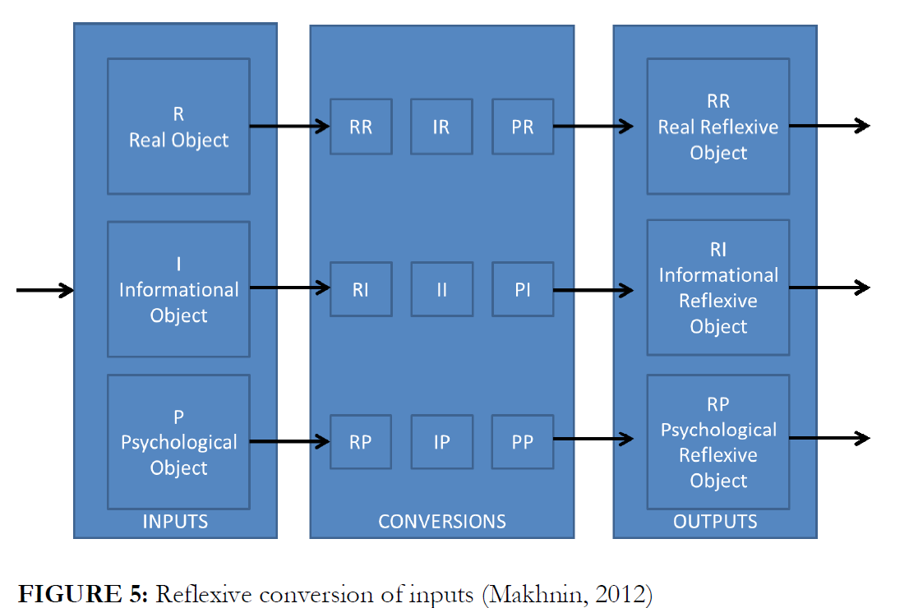
In accordance with the figure above, different ways of producing variations can be defined. Makhnin presents the variations of real-world objects, information world objects and variations of psychological impacts and the resulting categories of simulacra. By doing this, he expands the concept of reflexive control beyond the concept of information operations. (Vasara, 2020, 54)

In Makhnin’s view, the key elements of reflexive influence are as follows: 1) the inputs creating the influence; 2) order of the inputs; and 3) the procedures used to create information packets. The fourth important thing is to identify the reflexive techniques used by the enemy and against which protective measures must be taken. Like Lefebvre et al., Makhnin also identifies two different principles for applying reflexive control: the first principle is to use predetermined simulacra so that the enemy can be induced to select the desired line of action. The second principle is to use simulacra with a vague chain of action [suggestibility not pre-definement]. This means that the enemy uses the information as a basis for its own action and can choose between a number of different options. One must be able to shape one’s own action on the basis of the option selected by the enemy. (Vasara, 2020, 54) According to Makhnin, reflexive actions are at their most effective when replacing rational stereotypic algorithms with entirely new methods and tactics and take the enemy by surprise. Likewise, reflexive actions can disorientate the adversary’s command and control system by paralyzing its components, one by one. (Vasara, 2020, 55)

Combining Lefebvre’s theory and the ideas of Makhnin described above, Kazakov and Kiryushin note that in Makhnin’s view, key to reflexive control is the chance to generate influences preventing the enemy from using new information, to paralyse the enemy’s creativity and to prevent the enemy from making full use of its combat potential. They note, however, that it is equally important for a researcher of reflexive control to identify the messages essential to reflexive control (the information packets used
by the enemy as a basis for its decision-making). Like Makhnin, they recommend that the term ‘simulacrum’ should be used. In their view, it provides an adequate theoretical basis for the information packets used for deceptive purposes. They note that such information packets should be divided into two general models: representational and non-representational. A representational information packet is a copy of a copy (pretending to be the real thing). In the context of reflexive control, such information packets are used when one wants to conceal one’s intentions. The information is partially
false but its sole purpose is to conceal the real information and to deceive the enemy A non-representational information packet, on the other hand, does not pretend to be a copy of a real thing. Its purpose is to act as a cover for the original matter and to convey false information about a matter, action or an event. (Vasara, 2020, 56). As Vasara has noted it is also important to realize that there are two simultaneous processes going on, 1. the RC of the adversary and 2. mission management: moving around troops as RC is running to respond to the outcomes of forcing the adversary around the battlefield based on RC.

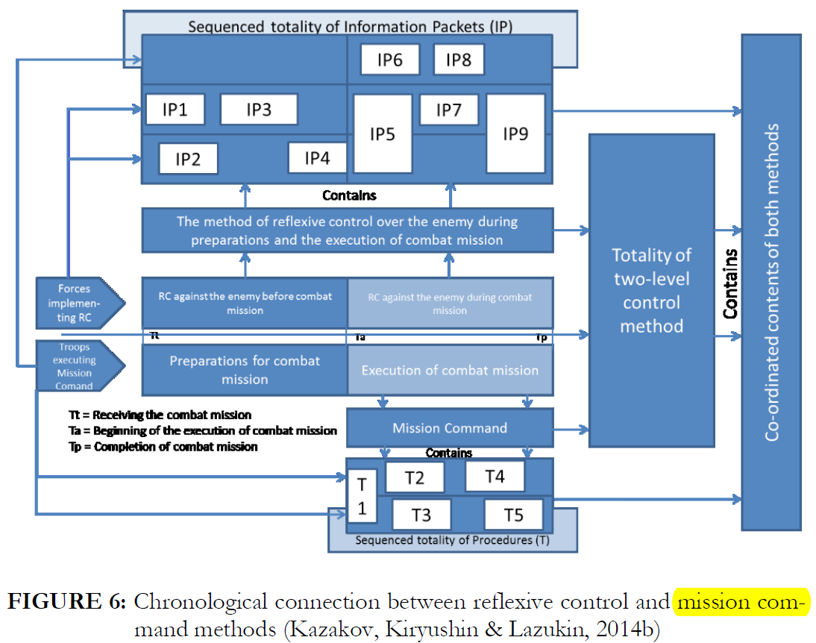
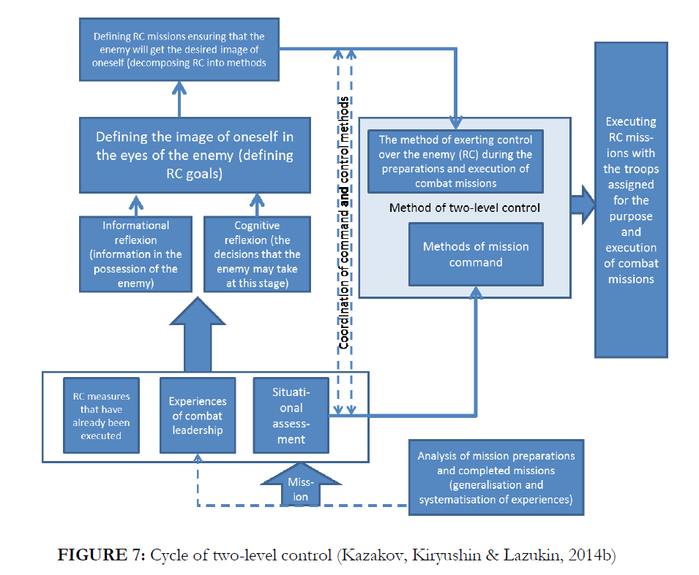
(graph from Vasara 2020)

The model described above shows that the implementation making use of constructive reflexive control can be based on any of the three inputs. The real inputs are based on the action of one’s own troops, while the informational and psychological inputs are based on the starting point or situational data created for the enemy’s decision makers that is advantageous to one’s own side. Using these inputs as a basis, the enemy is expected to voluntarily make decisions that are advantageous to one’s own side and that one’s own side has been able to anticipate.

To complement this definition, a model has been prepared on the basis of the sources discussing reflexive control and presented above. It encompasses all aspects of reflexive control, from the methods of exercising it to its goals, using the division Ends-Ways-Means produced for strategy by Lykke. The essential feature of the model is that, in accordance with the ideas presented by Lefebvre and Makhnin, it is divided into two implementations: constructive (creative) implementation, employing procedures aimed at inducing the enemy to make desired decisions, and the destructive implementation, employing methods attempting to weaken and disrupt the enemy’s decision-making (Ways). The model also features different types of reflexive control, different forms of control inputs and different methods for exerting reflexive control (Means). The model combines all these factors to illustrate the areas of the military command system targeted for the influencing efforts (Ends). (Vasara, 2020, 62)

There is one key element to remember in dealing with RC, that is that without a valid model of the adversary you have a useless tool that will continue to attack phantom targets rather then real targets.
This is because the whole concept is based on the assumption that the enemy’s decision-making can be modelled so that using specific prepared inputs, the enemy can be persuaded to take the decisions anticipated and desired by the other side. (Vasara, 2020, 67). As the processes of RC become more and more AI driven and automated the question of a valid model becomes increasingly important. Another important understanding of the functionality of RC techniques is that of targeting the interpretation of objects, in Semiotics the Interpretant (Subject), this can be affected through various means, such as providing false interpretation of scientific data by paying experts to mislead with half-truths for instance to obfuscate military capabilities. Franke, gives a fuller understanding:

Ulrik Franke, a Swedish military researcher, has written a study of information warfare, which relies on Russian documents as source material. Like Makhnin, he highlights the use of real, informational, and psychological inputs in the conveying of information. According to Franke, the following measures can be used during peacetime: attempts can be made to discredit foreign politicians; messages can be sent by means of aggressive air operations; or Russian views on the world situation can be conveyed through suitable media (Franke, 2015, p. 51). However, as required in the implementation of reflexive control, more importance is attached to the adversary’s interpretation of the activities than to the activities themselves. (Vasara, 2020, 68)

One example of messing with interpretations is that of using social networks to plant fake news which is not totally fabricated usually but are half-truths. Social networks can be used to influence individuals’ behaviour and their beliefs and such action provides a basis for the use of legal ‘agents’. (Vasara, 2020, 61). It is telling that with the new technology of decentralized networking via computers that it has opened a new door to operations of RC, and that military planners view the members themselves of these networks as valuable ‘agents’ even if unknowing. This handling of these agents “can be applied using real and information inputs that mainly comprise surprise/
deception by one’s own troops or the feeding of information to the enemy’s
system and decision-makers that creates confusion on the enemy side or is otherwise
harmful to the enemy. These inputs are expected to destroy, weaken or paralyze the
enemy’s decision-making capacity.” (Vasara, 2020, 65). lt should be noted by others that Russians do not allow their soldiers to actively participate in social networks, especially on deployment, one can also testify to the vulnerabilities of allowing social network access while on deployment in the many encounters of US servicemen being targeted by the likes of ISIS and al-Qaida operatives through these networks.

Cyber Influence of RC
Operations Research as a part of Intelligence operations is a natural home for Reflexive Control, The intertwinement of Cybernetics and Reflexive Control is a long held combination, we can even see it’s influence today in the work of Serge Kernbach, a Professor of Robotics who also studies Soviet remote influencing. Again, cybernetics, being the study of control in the animal and machine, it is not surprising that a binary logic such as Reflexive Control grew out of the section that developed computerized algorithms, such as V. A. Lefebvre. As those old enough to remember the Soviet Union it’s dictatorship of the proletariat was a hierarchical directed graph. The notion of machine and man is not separate in Soviet culture. We look for instance at Soviet artistic expressions in ‘Constructivism’ which envisioned the mixing of man and machine, a new Soviet man. It is also expressed in the military organization of the Soviet Union where it was not difficult to envision total automation of military units, for instance we could look at the Alpha class of Soviet submarines with a skeleton crew of commissioned officers only and cybernetic control of most systems. This extended into other spheres of the Soviet military:

“In Soviet economics we therefore see Five-Year and Ten-Year Plans; in the Soviet military, a trend toward a cyberneticaly based theory of troop control (upravienie voyskami/silami, C²), and projection for the eventual total automation (ASUV) of the Command, Control, and Communications (C3) System.” (Chotikul, 1986, 29)

Finnish Military researcher Vasara drives down into the subtleties of Russian, a nuanced language, understanding of upravienie voyskami (command and control) in his work on Reflexive Control:

However, ‘management of troops’ is not the correct translation for the Russian term either. This translation fails to convey the fact that the Russian term refers to a successive management process and not merely to the direct action of commanding troops. ‘Giving orders’ (командование) is an instrument implementing the directing function, whereas ‘management’ (управление) implements the action itself. The fact that the Russian translation for ‘reflexive control’ is ‘refleksivnoje upravlenie’ (‘reflexive management’) and not ‘kontrol’ is also relevant to this study. Management is a dynamic process, which includes both inputs and feedback. In Russian, the word ‘control’ (контроль) is used to describe feedback functions and supervision. Thus, directing and execution are seen as two separate though continuous and mutually dependent (dialectical) functions (Hall, 1991, p. 132-133). (Vasara, 2020)

As we shall read later Soviet and later Russian military leaders viewed the connection of RC to operate in tandem with troop movements which necessitated not only RC of other troops but also as part of mission management to use cybernetics to command troops as Vasara notes:

Researchers studying the military applications of cybernetics proposed that computers and cybernetic control should not only be used in autonomous weapons systems but also in the command of military units (Gerovitch, 2002, p. 265). In fact, the first information technology centre operating under the auspices of the Soviet Ministry of Defence was the first facility to study automated command of troops. In the opinion of cyberneticians, computers can make more objective decisions than individual commanders because computers do not base their decision making on intuition but on collective information and on a broader operational-tactical view in specific areas. (Vasara, 2020, 15-6)

Vasara offered the following flow chart of command and control with cybernetic reflexive control, noting that #5 is a mirror image of the opposition to that showed in the flow chart as Red attacks Blue and vice versa.

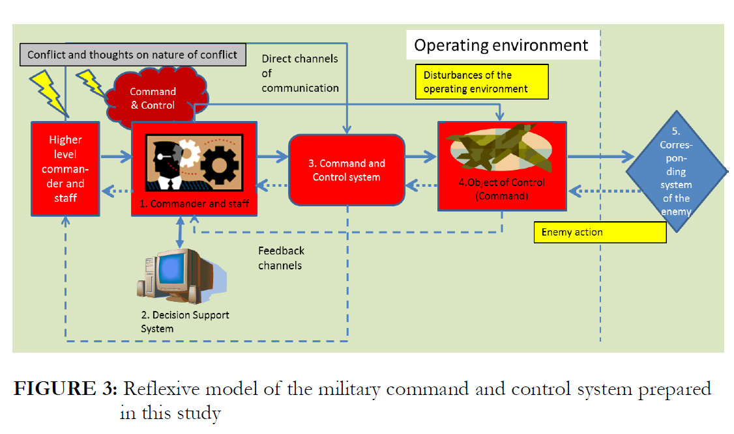
(Vasara, 2020, 27)

To further drill down into Russian understandings Vasara quotes a Russian General on command:

Volostnov and Golod put together earlier concepts in their search for the core idea of command and control. In their view, command is an intentional, creative, organizational and a technical process that is put into practice by commanders and their staffs. It creates impacts on the troops subordinated to them. The ultimate goal of command and control is to organize troops for their combat missions and to ensure that they can effectively carry out their combat missions within the time allocated to them and with minimum losses. Secondly, when examined through the cybernetic perspective, all command takes place in a closed cybernetic system, in which objects in contact with each other transmit information in an appropriate manner. Thirdly, the command process is part of the military system. In this connection, the principles defining the content of ‘control’ are those that define the functioning of complex military systems (Volostnov & Golod, 1992). (Vasara, 2020, 25)

It is an interesting difference between Western views and the Marxist dialectical view where everything is interconnected rather then viewed as having a more modular architecture.

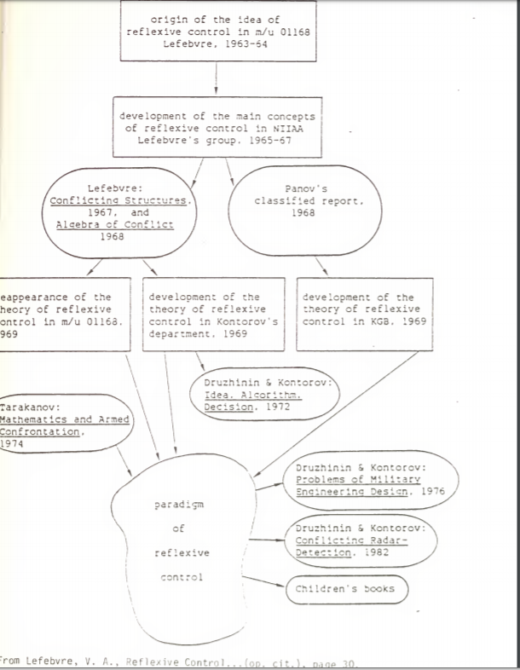
At least initially this willingness to trust cybernetics with management of troops themselves and automation of C3 was not shared in the West, for instance while serving on US submarines the main reason our Sonar system was not fully automated was this distrust of machine over human intuition, then again Sonar personnel are known for their deeper understanding of fluid natural situations then a machine could ever be capable of, but as US Forces get as stupid and fat as their civilian counterparts the move to Automation became inevitable. Returning to the concept of hierarchical control, realizing we are dealing with Soviet architecture it is not surprising to see a main controller, the main controller of all controller classes, the concept of ‘edononachalniye’, one man control (Chotikul, 1986, 61), finds itself even imported to the west later after the fall of the Soviet Union in Lockheed-Martin engineer Ed Nozawa’s ‘Single Warrior Model’ which is a closed loop self-management automated system based on Soviet research we see it previously, “...to the Soviet view of the leader as ‘sole formulator and controller’ of group decisions and actions.” (Chotikul, 1986, 62). In fact, according to the analysis of Vasara the prime target of Russian RC is the commander or leader:

In the context of this study, it is important to identify the potential targets for influence operations in this highly automated command system, which is designed for quick commander-centred decision-making. It can be concluded from the above that the commander is likely to be the prime target and the staff the secondary target. This is because influencing them will impact the whole system (in the same way as exerting influence on a higher-level commander). Influence on the commander and his staff can be exerted through their thoughts (command and control and thoughts about the conflict as background factors), through the plans that they have prepared (the aim is to influence the fundamentals of the plans), or through decision support systems (solutions advantageous to one’s own side are fed into the decision-making process). Efforts may also be made to exert direct influence on individuals (especially the commander). Efforts may also be made to influence the command system, even though this will produce more limited results. The ultimate method of exerting influence on the enemy is to cause more disruption in the operating environment. All these options are discussed in the dual model of reflexive control. (Vasara, 2020, 28)

Softening up of a target of Reflexive Control, the subject, is another area that goes hand in hand with RC. In this battle between opposing RC agents the mind becomes the seat of conflict, the Russian Generals are very aware of this both in terms of counter-measures and in offense. Vasara citing the influence of Gen. Ryabchuk, “intellectual capability is the key weapon and crucial to achieving
victory over a well-armed, well-equipped and well-trained enemy (Ryabchuk, 2001,
pp. 14–15).” Another General, Makhnin reached similar conclusions. (Vasara, 2020, 26). One of the most important contributions from cybernetics to Command and Control in the SU was the creation of decision aides to guide commanders decisions. However, even with the added tool of automated data mining and simulations, the mental strength of the commander is the key according to Ryabchuk, Vasara notes:

Ryabchuk concludes his article by noting that today’s military commanders have access to more systems helping them to select the best possible options when making decisions. Nevertheless, in his view, success in the battlefield is guaranteed by the personal characteristics of a military commander, which comprise a high intellectual capability, high ethical standards, and psychological and professional capabilities. When available in sufficient quantities, these characteristics provide a basis for an effective approach to command and control (Ryabchuk, 2001, p. 17). (Vasara, 2020, 26)

For a Commander when dealing with RC and it’s necessary cybernetic underpinning one of the key attributes of success is maintaining an analytical mind as well as applying ‘exploration’ in tactics. Decisions are usually made according to the Recognition-Primed model of Klein which states that decision makers make quick decision based on previously experienced patterns, without analyzing different options. In such an automated system this would lead to being quickly out maneuvered. Another mentally weak strategy in RC for a commander is to too quickly make decisions, avoid knee-jerk responses which may even be conducted with RC psychological inputs to promote such knee jerk responses. It is important to understand the systems a commander is faced with, that these systems of complex reflective systems, taking into account decisions made by the adversary in their own actions and try to achieve a higher degree of reflex (Vasara, 2020, 22).

The notion of using PSYOPS to achieve this softening up the thinking of adversarial commanders is one of the processes of RC:

“And secondly by the Soviet study of the psychology of attention This academic discipline and, in particular, its research on the ‘orienting reflex’ has convinced the Soviets of the value of inducing psychological strain and inability to cope through inhibition of the ability to establish patterns. These repeating techniques, coupled with an emphasis on redundancy, would thus appear to be very effective tools in the attempt to reduce risk and create “right conditions’ to gain advantage, and possibly even control, over an adversary. As Beaumont has noted, “The cross-links between Soviet psychology, the military and engineering are far more well developed than in the West and have been since the Revolution.” (Chotikul, 1986, 76)

Although it is not true that the union of psychology and warfare is not found in the West [perhaps not mentioned do to a need to know restriction of the military author], it is important to understand the linkage. On the Battlefield, in this case a physical space, the Commander is going to establish full-spectrum dominance they are going to want to control the terrain, the heights, the valleys, the beach, etc. This is also a part of effective RC, hence the softening up process is also a means of extending dominance of the environment, removing unknown factors or variables, thus controlling even the inputs to the Reflexive algorithm:

Important considerations to the Soviets when attempting to optimize a decision are: what is the nature of unknown factors, what is their origin, and who controls them. Measures of effectiveness (MOEs) in Soviet operations research take these unknown factors into account into their algorithms, and attempt to optimize effectiveness in spite of them. (Chotikul, 1986, 86)

The Soviet military put a lot of emphasis into Reflexive Control in the 1970s and 1980s, of course one questions it’s validity considering the Soviet Union collapsed like Nazism, but nonetheless military planners in the Soviet Union and now the UKUSA have fully embraced the edicts of RC. The problem is that in militaries around the world, most will simply mimic each other, as the SU creates RC, then the UKUSA must also create RC and RC counter-measures. referencing the work of Lt. Col. Timothy Thomas (US Army Ret) currently a contractor for Defense Industry Company Mitre Corp, who has perhaps the deepest academic understanding on Soviet RC then anyone else a Soviet military leader Col. Leonenko explains the importance of knowing RC and applying it to the enemy:

If successfully achieved, reflexive control over the enemy makes it possible to influence his combat plans, his view of the situation, and how he fights. In other words, one side can impose its will on the enemy and cause him to make a decision inappropriate to a given situation. Reflexive control methods are varied and include camouflage (at all levels), disinformation, encouragement, blackmail by force, and the compromising of various officials and officers. Thus, the central focus of reflexive control is on the less tangible element of “military art” rather than more objective “military science.” Achieving successful reflexive control requires in-depth study of the enemy’s inner nature, his ideas, and concepts, which Leonenko referred to as the filter through which passes all data about the external world. Successful RC represents the culmination point of an information operation.
So defined, a filter is a collective image (termed “set” [see Bernstein above]) of the enemy’s favorite combat techniques and methods for organizing combat actions, plus a psychological portrait of the enemy. Thus, reflex requires study of someone else’s filter and the exploitation of it for one’s own ends. In the information age, this filter is represented by human and machine (computer) data processors. The most important question then becomes, How does one side achieve this higher degree of reflex and, hence, more effective reflexive control over the enemy? It does so primarily by employing a broader range of means for achieving surprise. In turn, it achieves surprise by means of stealth, disinformation, and avoidance of stereotypes [shablon].11 (Thomas 2004, 242-3)

You might compare the process of Reflexive Control to a normal war, except the Battlefield is of the Mind, wherein you use various tools for manipulation, intimidation, honeypotting, psychological torture, rewards, payoff, a combination of both positive and negative feedbacks even physical violence to steer your opponent to your will, while hiding your true will and goal from your opponent, it is a hidden war. This is all done in an effort to hamper, hinder and sabotage the opponents decision making process, time and methodology, to sow confusion at every turn.
Another Soviet military leader, Col. S. A. Komov, has presented the following list of elements of RC in military decision making:
• Distraction, by creating a real or imaginary threat to one of the enemy’s most vital locations (flanks, rear, etc.) during the preparatory stages of combat operations, thereby forcing him to reconsider the wisdom of his decisions to operate along this or that axis;
• Overload, by frequently sending the enemy a large amount of conflicting information;
• Paralysis, by creating the perception of a specific threat to a vital interest or weak spot;
• Exhaustion, by compelling the enemy to carry out useless operations, thereby entering combat with reduced resources;
• Deception, by forcing the enemy to reallocate forces to a threatened region during the preparatory stages of combat operations;
• Division, by convincing the enemy that he must operate in opposition to coalition interests;
• Pacification, by leading the enemy to believe that pre-planned operational training is occurring rather than offensive preparations, thus reducing his vigilance;
• Deterrence, by creating the perception of insurmountablesuperiority; RUSSIA’S REFLEXIVE CONTROL THEORY
• Provocation, by force him into taking action advantageous to your side;
• Overload, by dispatching an excessively large number of messages to the enemy during the preparatory period;
• Suggestion, by offering information that affects the enemy legally, morally, ideologically, or in other areas; and
• Pressure, by offering information that discredits the government in the eyes of its population.27
(Thomas, 2004, 248-9)

As one can see from this list a large amount of emotional and psychological pressures are formulated in the process of RC. One may think that only national leaders or Generals would be subject to this kind of campaign, however, it is noted that this is to be used against even local commanders in military operations, of course to psychologically manipulate someone you have to have solid information about their psyche, the inner world, their behaviours, the predicted responses, the methodology for achieving this psych profile has become increasingly invasive, see Quantum Consciousness chapter for how this achieved.
As mentioned earlier the primary difference between modern RC and ancient RC is that of technology. Since the creation of computational system in war fighting with the advent of the computer in combat during WW2, it has also come into play in RC with the automation of RC under the Soviets, who at one time enjoyed an almost 2 decade advantage in computer power compared to the United States in the 1980s, in other words the Soviets had far outpaced the UKUSA in terms of computational and psychotronics in the 1980s but still lost the Cold War, like the Nazis in Russia in WW2, natural power trumps artificial power, as the Russian winter defeated the Nazis. The use of big data in RC was first accomplished by the Soviets. Col. S. Leonenko was one of many architects behind the integration of early AI systems into processing RC. He has pointed out, “that the use of reflexive control by making it easier to process data and calculate options. This is so since an opponent can more easily ‘see through’ a reflexive control measure by an opposing force by simply using a computer. The computer’s speed and accuracy in processing information can detect the reflexive control measure. On the other hand, in some cases, this may actually improve the chances for successful reflexive control, since a computer lacks the intuitive reasoning of a human being.” (Thomas, 2004, 246). Leonenko draws attention to the problem of involving computer automation in such military operations as RC. He stated, “we live in a much more frightening existence then we care to believe if, in fact, decisions are in the hand of machines that are ‘incapable of assessing what is occurring and do not perceive that a person reacts to” (Thomas, 2004, 247). Automated Weapons researchers also note that computers also do not experience guilt and remorse regarding to their actions as well it provides a layer of emotional insulation to human decision makers, when a machine is the main instrument of conducting wet operations. In a later section we will be reviewing the automated aspect of computer management systems of Reflexive Control.

Situational Awareness and Management
As we shall read later regarding Western development of software that manages military simulations situational awareness and management is a key to effective military operations regardless if they include an RC component, although it is safe to say that every modern military action includes RC. Managing situations becomes a cornerstone to the understanding of RC. Lefebvre viewed conflict no longer as between two physical armies rather the conflict was an interaction between two decision-making processes which have a feedback loop onto how the troops are managed and deployed (Vasara, 2020, 34). Lefebvre’s definition accords that the other party gains leverage over the adversary’s situational assessment, this in tandem with studying and knowing the highly probable moves of the adversary, it is possible to create an equation of the options available to decision-makers. Vasara notes it is particularly important to be able to influence the adversary’s situational awareness, his goals or doctrine and to ensure that the adversary does not notice the influencing attempts (Lefebvre, according to Chotikul; 1986, p. 78).” (Vasara, 2020, 35)
Of course this then would necessitate the use of deception to hide one’s own plans as well as a random use of randomness to offset the pattern of an equation.

Major General M. Ionov notes that influencing is possible if the plans and intentions of the enemy are revealed. According to Ionov, the enemy can be persuaded to make decisions that are to one’s advantage based on the following conditions: the enemy is placed under pressure; influence is exerted on the enemy’s situational assessment, decision-making algorithm, and the way in which it selects its goal; and influence is exerted on the timing of the enemy’s decision-making. Placing the enemy under pressure is the easiest condition to understand. Its aim is to influence the psychological state of decision-makers and to persuade them to avoid combat. Disguise, deception, unexpected new instruments, and changes in troops are used to influence the enemy’s situational assessment (Ionov, 1971, p. 165). (Vasara, 2020, 36)

As it can be seen controlling the situation becomes one of the key parameters in a conflict. One western researcher has come to the following conclusions on the necessity to have the situational upper hand:
...goal setting can be influenced in three ways. One is a show of force to convince the enemy that a goal is unachievable. A second is to demonstrate a threat of such significance that its countering dominates the enemy’s goals. The third way is to keep the enemy in a state of uncertainty concerning one’s own actions to ensure that none of its goals can guarantee a satisfactory outcome in all plausible sets of events (Reid, 1987, p. 295). (Vasara, 2020, 39)

Vasara gives a list of successful tactics used in controlling the situation and setting the goal state:

– Transferring a situational picture to the enemy: in this method of reflexive
control, the enemy is conveyed a wrong or incomplete situational picture by
means of deception, disguise or decoys (Reid, 1987, pp. 296–299).
– Creating goals or a doctrine for the adversary: in this reflexive control method,
the aim is, by sharing one’s own information, to put the enemy in a situation
where its only options are also advantageous to one’s own side (ibid., pp. 298–
300).
– Transferring the desired decision: in this operating model (which requires trust
and contacts between the parties), the aim is to force the enemy to make a
decision that provides a basis for action on one’s own side (ibid., p. 301).
40
These three operating approaches are simple models, in which the aim is to directly
influence the adversary’s situational assessment at specific stages of decision-making.
The operating models described below are more complex because in them, the aim is
to shape one phase of the decision-making process by controlling the adversary’s understanding
of another phase. Success in such actions requires extremely good understanding
of how the adversary makes decisions (Reid, 1987, p. 301).
– Influencing goal formation by feeding a false situational assessment: feigning
weakness so that the enemy can be lured into a trap is one application of this
method (ibid., pp. 301–302). This model can also be used by controlling specific
‘indicators’ identified in advance that the enemy uses as a basis for its
decision-making.
– Feeding parts of one’s own situational assessments to the enemy: for example,
controlled leaks concerning matters presented as important to one’s own operations
(ibid., pp. 302–303).
– Feeding details of imaginary goals to the enemy: the purpose of this method
is to shift the enemy’s attention away from one’s actual goal to the desired goal
(ibid., pp. 303–304).
– Feeding a fake version of one’s own doctrine to the enemy: exercises, in which
the troops are deployed differently than in the real situation are an example of
this method (ibid., p. 305).
– Modifying one’s own action so that the enemy gets a wrong situational picture:
in this method, one takes a controlled risk and moves troops to an area from
where no attack is planned. The assumption is that the enemy expects an imminent
attack (ibid., pp. 305–306).
– Reflexive control of bilateral engagement by a third party: in this method
(which is directed at decision-makers), a third party attempts to get two other
parties into a situation that is advantageous to it (ibid., p. 306).
– Reflexive control over an enemy applying reflexive control: in this operating
model, it is assumed that the adversary is using reflexive control, and the aim
is to uncover its stratagems and to use them against the other side (ibid., pp.
306–307).
– Reflexive control over an enemy relying on the game theory: in this method,
which is based on the conservative nature and inflexibility of the game theory
and answers known in advance, inputs in line with these characteristics are fed
into the adversary’s decision-making process (ibid., pp. 307–308).
(Vasara, 2020, 39-40)

A WOPR of a Decision Aides:
In the Russian and earlier Soviet research regarding RC it is noted that automation and information technology greatly expand and also limit the effectiveness of RC. In terms of amplifying RC the sheer iterations that a machine can throw at an adversary can potentially paralyze their response do to the simple number of automated attack vectors, but for the same reasons of losing effectiveness do to automated detection of RC techniques the same machines can undo attacks along with making attacks of one’s own more effective. This was not lost to Russian military planners such as Ionov as early as 1971:
Ionov concludes his article by noting that influencing the enemy’s operations constitutes a complex logical problem that can only be solved if a large amount of information is processed. This is beyond the capabilities of the commander and his staff and automated systems are required for the work (Vasara, 2020, 37)

Earlier we mentioned that in Russian Cybernetics there is a trust in full-cycle automation, that is there is no human in the loop of automated management, though not as popular as the form of having a human commander reference automated data procedures as a form of insight or recommendation, which is conducted by Decision Aides. Russian military planners write regarding Decision Aides:

Tikhanitsev, who works at the research department of the Russian military administration and actively contributes to the debate on research issues, has written about developing decision support systems for automated administration. He notes that in the context of the systems theory, the individual who decides to launch an operation (battle) merely adjusts the control parameters in order to construct a strategy allowing weapons systems and troops to achieve the goals set by the commander (within the limitations set). If there is only one solution to such a system-level problem, it can be determined by means of direct calculations. However, Tikhanitsev admits that in combat troops are rarely in such a situation. If there are not enough troops or weapons, the goal can rarely be achieved with the prerequisites set. In such cases, in order to achieve a solution, new values for the target function (goal) must be calculated or estimated or some of the limitations must be adjusted. In that case, a rational solution can be achieved but solving the equation involves a large number of changing parameters and producing the calculations is difficult. Reaching a solution may prove impossible unless the decision-makers use the capabilities offered by automated support. (Vasara, 2020, 23)

Although it is hard to imagine that human soldiers would just be moved around a battlefield like tin soldiers of competing machines, the reality is that is what warfare has become, whether the soldiers are directly controlled by a machine or still maintain their own consciousness in battle through the thin line of a human commander interacting with a machine, we are confronted with a situation in automated warfare where even the soldiers themselves are mere puppets to an automated system, as we have read in ‘Lessons from an American Weapons Developer’ it has already been investigated in the United States military of using EM to control soldiers body states and the use of Decision Aides in Lockheed Martin’s work on Reflexive Games based on AI POMDP Algorithm competing agents of Red and Blue.

The downside of using automated decision support is that those decisions themselves could be based on disinformation, data poisoning, or just bad math. The article by Donskov, Nikitin and Besedin on intelligent decision support systems for electronic warfare is relevant to reflexive control. In their view, decision support systems used today are typically built as expert systems that support decision makers without them having to take any active measures. In the authors’ view, the risk here is that the adversary can manipulate these automated systems with its signals. They note that as systems become more extensively automated, it becomes increasingly likely that there are attempts to control them on a reflexive basis. According to the authors, a decision support system may in itself exert reflexive control over the enemy and protect one’s own system against the control attempts made by the adversary. (Vasara, 2020, 23). It is not trivial to realize that any group with appropriate knowledge can poison an automated system, for instance when Microsoft’s AI came under attack from a Neo-Nazi styled attack which trained the AI to produce Nazi aligned beliefs in it’s comments.

Fast Reflexion: Overriding Individual Control

In the 1980s V. Lefebvre came up with a new concept in Reflexion studies that of Fast-Reflexion, reflexion that happens at an automatic unconscious level, operating at a rate faster then consciousness in the milliseconds range.

Fast Reflexion:
Our view of “reflexion” has been essentially broadened during the last twenty years. Traditionally we have considered it to consist of the conscious constructing of images of the self and others by human beings. Now we have evidence that there is a reflexion of another nature as well. It is as if an inborn informational processor is built in into human psyche whose function is to automatically create these images together with their subjective domains. This processor generates a specific specter of human responses not controlled consciously and running extremely fast (one-two milliseconds). This type of reflexion, as distinct from the traditional concept is called fast reflexion (Lefebvre, 1987) [not controlled by one’s self-will, an entirely subconscious process] (Lefebvre & Webber, 2002 )

In Lefebvre’s Algebra of Conscience he postulates a pole between liberal western values and authoritarian eastern values. Which are diametrically opposed to each other. Agents within these two systems are given their position by the pressures from others. An Agent creates an image of self and an image of other and even more complex images of reflexion.

“the image of the self plays the role of the subjects conscience, seeing oneself as ‘bad’ prevents one from choosing the negative pole.” (Lefebvre & Webber, 2002, 3)

Ideally, global theoretical models ought to possess two properties: integrity and uniformity. Integrity means that the model must be able to reflect simultaneously the subject's perception, behavior, and inner domain. Uniformity requires that different aspects of the subject's activity must be described in terms of the same theoretical language. The general method for attaining these two properties is to represent the subject as a composition of mathematical functions. Various elements of this composition are interpreted as "inputs" and "outputs" and as images of the self and of other subjects. These images can have their own inner domain containing images of the next order. As a result, we succeed in producing a unified functional description of the subject's inner and external activity. A composition of mathematical functions is also a function. It describes the subject's behavior. Therefore, the composition's structure reflects not only the subject's inner domain, but also the macrostructure of a computational process generating behavior. In the simplest cases, when the
"global" function of behavior is known in advance, information about the mental domain can be obtained from a purely mathematical analysis of the properties of the function.
(Lefebvre & Webber, 2002, 1)

Lefebvre formula for images of self and others:

X1 = f(x1,x2,x3) //values [0,1], describes the subject’s readiness to choose the positive pole [willing to be controlled]

X1 = F(x1, F(x2,x3)) //F(x2,x3)

x₁: worlds pressure toward the positive alternative A at the precise moment of choice.[swarming seems to occur at this moment] Normalized utility- measures of the alternative Sets A,B
x²: worlds pressure toward A which is expected by the subject based on prior experience. Normalized expected utility measures.
X³: subjects intention to choose the positive pole. greater the x3 val; greater the desire (compliance) to make the choice.

Function F(x,y) describes subject from his perspective and external points of view [when targeted ignore external points of view since they are all manufactured and meant to mislead]

x – image of the input
y- secondary image ‘model of the self’ not just subjects intention from which obtain a formal analogue of the macrostructure of the subjects inner domain:

F(x¹, F(x²,x³)) this structure describes the process involved in the cognitive computation of X:
      - X² = F(x²,x³) is computed, and then

      - X¹ = F(x¹,X²)
So it becomes obvious from the above that in Reflexive Control the polluting the ‘image of the self’ becomes the focus of informational confrontation.

Composition of Mathematical Functions (representation of subject or target)
describes the subjects behavior, therefore the compositions structure reflects not only the subjects inner domain, but also the macro-structure of a computational process generating behavior.

The hypothesis of existence of the inner processor for generating fast reflexion can be described as follows (Lefebvre, 1985):
(1) A person possesses an inner formal mechanism for modeling the self and others. This mechanism is universal and does not depend on the particular culture to which a person belongs.
(2) The models of the self and other are reflexive; that is, these models may themselves contain models of the self and other, and so on.
(3) The inner formal mechanism for modeling includes a computational process, which is automatic and does not depend on conscious will. This process predetermines a person’s responses in a situation of choice between “good” and “bad”, and it also generates his inner feelings, such as
guilt and condemnation.
(4) The models of the self and of the other also have this computational ability, which allows a person to model automatically his own and his partner’s inner feelings, providing information that is unavailable to direct observation.

Automatized and Deliberate Choice
deliberate- “a person sometimes [probability, random factor] consciously plans and then performs an action as planned”
automatized- while other times the phase of conscious planning is absent

mixed cases are possible in which intention x3 influences X1 but does not entirely determine it.

The Russian Allegation of Neurowarfare Attack by the West

In the chapter “Quantum Consciousness and Neuroweapons” I review the work of Okatrin, noting a CIA interview with him regarding the ability of remote influencing. Okatrin noted to the CIA that he was only aware of Western attempts at such technological control or mass influencing. Which is probably dishonest but as a member of the Soviet Academic community he would as a Government employee of the Soviet Union disavow any such work. Apparently this is contradicted by memos regarding official Soviet interest in controlling biological objects. However, the claim that the west is interested in such technology is also brought forward by Brushlinsky’s replacement in charge of Russian Reflexive Control Vladimir Lepsky, in his work also claims that the west is interested in controlling the East, that is Russia, through such technology, creating an oligarchy, through a form of ‘organized chaos’ citing DoD funded researcher Mann’s chaos ideals in geopolitics, charging the west with the managed chaotic destruction of Russia. In 1992, “according to Lazarev, the United States uses information as a reflexive control instrument, and for this reason, information security of the state must be given a high priority.” (Vasara, 2020, 42) Then there is also the work of Sokolov that claims that the attacks on people in Russia working on these technologies has led to losing such talent to England who are now working against Russia. Then we can also look at the 2015 claim by the Russian Press Secretary Peskov that Russia was under ‘Anglo-Saxon’ information war as noted by one opinion piece author:

...Peskov also spoke about the information war "primarily with the Anglo-Saxons" on March 26 on the air of the TVC. And, as if by way of illustration, the Kremlin's Russian Institute for Strategic Studies released a report "Foreign media in 2015 - an anti-Russian vector." Information war will write off everything. If a country is in an information war, it means that the state does not need feedback from society, and socially significant facts are transformed into state significant ones. Their significance can only be determined by the ruling elite; a mobilized society must obey orders.
https://www.vedomosti.ru/opinion/articles/2016/03/29/635450-informatsionnaya-voina-vse-spishet

Yet, looking back in history it is important to note the Nazi plan to colonize Russia and displace the Slavs with Aryans, with those Nazis who were serving to that purpose during the war then after the war heading to western intelligence organizations set to defeat the Soviet Union, Russia. So the question is whether this is a cultural artifact or an actual reality that the Russians are under a form of neurowarfare, a soft form of open warfare?
Interest in the west in Russian Reflexive Control is known through the work of Miller and Sulcoski in 1999 who proposed application of a model based on multi-attribute utility function (MAUF) in automated decision support systems. The model represented a chain of binary choices, for each of which its own reflexive model can be built. Taran (2002) elaborated models of multi-criteria reflexive selection and researched conditions that create prerequisites for management of a subject’s behavior under decision making. In collaboration with Shemayev (2005) she also proposed an approach to solution of problems of cognitive conflicts modeling, considering the influence of the external environment, psychological set and intentions of subjects. (Shemayev, 2017) Other Americans that have studied in Russia include Dr. John Norseen and Ed Nazawa both of Lockheed Martin. Earlier work in the American equivalent of RC:

...the focus in the Western approach to influencing opinions and impressions (perception management) is to steer the emotions, motives and objective deduction of foreign audiences and decision-makers by conveying to the target audiences selected information and indications or by preventing the target audiences from accessing information. This action is based on presenting the truth in a desired manner, operational security, deception and psychological operations. In addition to (or instead of) the term ‘perception management’ the term ‘strategic communication’ is now also used in the West (the concept originated in the United States). It is described as a government-level activity in which the aim is to reach target audiences, and create, strengthen or preserve conditions that are in one’s own interests. Strategic communication is carried out using a variety of different methods and all channels available at government level. Analysis of the target audiences and decision-makers and of the way in which the emotions and motives of the target audiences should be understood (subjective background factors) is a key component of these methods. In the subjective (understanding) approach to target audiences and to selecting information, there is a need to use a feedback channel: measuring and assessing whether this action is creating the desired impacts or whether the action should be adjusted in accordance with the feedback has been part of the Western way of influencing opinions ever since the Second World War. (Vasara, 2020)

It is important to note a key difference here between the Russian model of control and the American model of control, with the American architecture including a feedback loop to measure the result of the action against the target. Whereas, the Russian system lacks such feedback loops. The use of feedback loops of this type can be also considered similar to the use of Polling in Video Game design to measure the game state, registering actions and results through an Agent. As Vasara has noted about this distinction:

This differs from the Russian approach described in this study: in it, the aim is to determine the situation in advance, and to plan one’s own action and the sending of the information in such detail that there is no need for any feedback channel. (Vasara, 2020, 78)

It is important to remember that US contemporary influence technology is based in some degree to Russian designs that came to the west in the early 1990s after the collapse of the Soviet Union, such as Igor Smirnov who worked with the FBI at Waco and also had partnerships with former US military officials. Parallel to the war against terrorism launched by the United States in 2001, Russia under Vladimir Putin was working to achieve rapprochement with the West. In those years, there was more public discussion of reflexive control and reflexivity, and Russian researchers were engaged in close cooperation with their US counterparts. In 2001, Vladimir Lepsky, who had collaborated with Lefebvre since the 1960s, launched the publication Рефлексивные процессы и управление. Between 2001 and 2004, it also appeared in English under the title ‘Reflexive Processes and Control’. (Vasara, 2020, 45-6)

The question of the scope of Russian Cybernetics often comes up, with RC being designed in Russian engagements at the more command level rather then the geopolitical level, it is noted by Vasara that there was a sentiment of the US being interested in influence operations for this purpose:

In fact, the operational level only became a topic of discussion in the 1980s. This was prompted by American researchers who noted that reflexive control is a useful tool at strategic level and that the Soviet orientation is systemic-strategic compared with the technical-tactical approach favoured in the United States (Chotikul, 1986, p. 35). (Vasara, 2020, 67)

Vasara then cites US Army Lt. Col. Thomas regarding interest in higher levels of control:

In his book ‘Kremlin Kontrol’, Thomas notes that reflexive control can be applied at tactical, operational, strategic and geopolitical level (Thomas, 2017, p. 178). In fact, for the people behind the theory of reflexive control and for those responsible for its practical applications, the issue of operational levels has not been a prime concern. In their view, it should be applicable at all levels listed by Thomas when used in combination with different methods. The activities should be directed at the adversary’s decision-makers regardless of whether they are heads of state, Members of Parliament or battalion commanders. (Vasara, 2020, 67)

Then there is the warning regarding future Behavior Wars, obviously between the US and Russia, which Vasara relates from the 2017 work of Kiselyov:

In Kiselyov’s view, the focus should now be on warfare directed at behaviour. Such warfare has only become possible in recent years as methods have been developed to collect large amounts of data on human behaviour. Human behaviour is not only based on ideas, values, and beliefs, but it is also to some extent founded on stereotypes, habits, and behavioural models. At the same time, our behaviour is also shaped by official and unofficial institutions. Kiselyov goes on to note that there is indisputable scientific evidence that human behaviour largely takes place in semi-automatic mode and is based on habits and stereotypes. In his view, this not only applies to simple solutions, but the effect also manifests itself in complex decision-making situations involving choices that require in-depth thinking. (Vasara, 2020, 69)

Kiselyov then goes on to cite the US as pursuing behavior weapons:

Weapons influencing behaviour are the weapons of the future, and Kiselyov claims
that Western countries, especially the United States, are already developing them.
Kiselyov notes that it is particularly important to conceal the personal data of senior
officers to ensure the adversary is unable to anticipate their decisions in conflict. (Vasara, 2020, 70)

Would you like to play a Game?

In the 1980s there was a cyberpunk movie called ‘War Games’ in which a machine intelligence takes the world to the brink of Nuclear War by running simulations of scenarios. RC finds it’s most effective application in military planning and simulation programs. Games enter into RC thought and remain to this day to be used in military automated programs for conflict. RC grew directly out of reflections on Game Theory. Lefebvre later went on to found the concept of Reflexive Game Theory. Which is implemented in Military simulations in the former Soviet Union, and before in the SU. Remembering the cybersecurity Red (attacker) and Blue (defender) divisions we will see how Military planners via simulations and real world computer systems manage Reflexive Control, including the management of their own troops with algorithms based on RGT. Andrew Schumann an investigator into RGT defines it as:

The notion of reflexive games was first introduced by Vladimir Lefebvre in 1965. A game is called reflexive if to choose the action the agent has to model (predict) actions of his/her opponents. The game-theoretic mathematics for reflexive games has been devoloped by D.A. Novikov and A.G. Chkhartishvili. Notice that the ideas of Lefebvre are very close to ideas of metagame which were proposed by Nigel Howard. Level-k models are considered in. The difference between reflexive games and any bounded rational approach consists in that in reflexive games there is a massive-parallel logic [which may not be resolvable, always frustrated] that should be analyzed by the players for winning. In reflexive games both conflicting parties simulate decision making of each other and aspire to foresee them. This decision making (on the basis of reasoning as well as emotional reactions), which we expect from our interlocutor/opponent, are called perlocutionary effects of our dialogue. Let us recall that any dialogue has three levels: locutionary (information expressed in verbal or non-verbal ex-position of states of affairs), illocutionary (cognitive and emotional estimations of considered information), perlocutionary (effects of cognitive and emotional estimations of interlocutors/opponents). What will be the perlocutionary effects of our utterance, i.e. which decision will be made, we do not know, but we try to foresee them. The situation where my decision processes (cognitive estimations and feelings) are not transparent for the interlocutor, while his/her decision processes are transparent for me, shows that my level of reflexion is higher than my interlocutor's level. (Schumann, 2014)

Emotions, which are expressed in illocutions, are one of the main forms of reflexion. The
interchanging of emotions is always a reflexive game, a method of manipulation of others. (Schumann, 2018, 49)

The use of RC and Games is not just limited to the military though, it is used extensively throughout the Business and Political worlds, indeed the methods of RC are object type agnostic, can be applied to many classes of objects:

London et al. (2006) suggested a reflexive capability conceptual model for the individual in relation to e-business is developed which relies upon merging economic and social practices through an industrial organization economic theoretical lens and social science theories of communication. Studies of the reflexive approach in the sphere of market interaction of business entities are developing particularly actively. The researches deal with models of reflexive control of consumer demand (Petrachkova, 2007; Pokotilova, 2015), formation of supply chain and dealer network (Vandaele and Gemmel, 2007; Ustinov, 2011; Isikova, 2013), influence on competitor behavior (Malchuk, 2010), seller-buyer interaction during business transaction (Metcalf et al., 1992; Brigg and Grisaffe, 2010; Freydina , 2015). Hartmann et al. (2008) used the principles of reflexive control in modeling passive and active social interactions in marketing. Bettany and Woodruffe-Burton (2009) proposed a structured approach to the possibilities of critical reflexive practice in marketing and consumer research. (Shemayev, 2017)

From one such business implementation we could look at the work of S. Tarashenko, currently working for Mizuno Finance, a business of acquisitions and selling, regarding his research into the Reflexive Game Theory (RGT). Tarashenko defines RGT as “ model behavior of individuals in groups. It is possible to predict choices, which are likely to be made by each individual in the group, and influence each individuals decision making due to make this individual to make certain choices. Therefore it makes possible to control the individual in the groups by guiding their behavior by means of the corresponding influence” (Tarashenko, 2010, 1) The math behind RGT is based on Boolean Algebra and Set Theory, though some of questioned whether the math itself is flawed in RC and thus never truly workable, we will follow the Soviet lead and analyze RGT from a Boolean perspective as is the practice throughout the world’s military and intelligence fields. It is typical in RGT to assign all members of a population (individual humans or robotic autonomous agents) a Unique ID which is then represented on a fully connected directed graph, where each node is defined as either in ‘Alliance’ or in ‘Conflict’ with each other node on the graph. It is noted that mathematically conflicts are disjunction (summation) and Alliance is conjunction (multiplication), whereas the influences on a subject are held in a matrix. If a node views another node as a conflict, though the other node views them as ‘alliance’ the disjunction indicates a conflict relationship, which would suggest always a higher level of ‘conflict’ relationships. RGT- employs the fundamental principles of hierarchical organization on individuals and groups. To be able to control an entity in the RGT you put them in a group, and then try to influence the target by other group members and adversaries. The goal of the subjects in the groups is to choose the alternative from the set of alternatives under consideration through what is known as the Decision Equation, if one is not able to influence the targets Decision Equation the result is to put the target into a frustration state, although many targets or subjects are easy to influence there are some individuals and groups that are not easy to influence that are referred to as Super Active Groups (Tarashenko, 2010, 15), which would be outliers to the RC theory, when confronted with the inability to influence the subjects Decision Equation the alternative is to put the target into a ‘frustration state’-- neither a position of safety or of adverse influence.
To influence a subject or group it is necessary to formulate the Forward and Inverse tasks, as discussed regarding changing Brain states by Dr. John Norseen, here in the RC theory it is necessary to re-route the subject with these methodologies.

Forward Task: a task to find the possible choices of a subject of interest, when the influences on him from others subjects are given. [Target receives simulacrum to influence decisions as well as physical feedback from objects in the environment]

Inverse [Reverse] Task (Turning): a task to find all the simultaneous (or joint) influences of all the subjects together on the subject of interest that result in choice of a particular alternative or subset of alternatives. We call the subject of interest to be a controlled subject. [Target abandons own will and submits to the will of the influencing objects giving a win to the Controller, in normative robotics this would result in a successful trajectory or path being achieved.]


Novikov discusses creating two principals (red/blue or alliance/conflict in our discussion) that sets up agents that control the game and make decisions based on RC rules. Including the use of ‘phantoms’ fake agents for various reasons like manipulation and disinfo. The winner in the contested space or game will be the one that controls the ‘information equilibrium’ the best. In this case he discusses controlling economics in a game.

“From the game-theoretic viewpoint, the control problem of an ecological-economic system whose elements can demonstrate a purposeful behavior consists in the following. A control subject (a Principal) has to design a game of controlled subjects (agents) with some rules so that its outcome appears most beneficial to the former. Therefore, a necessary step of such control problems concerns game-theoretic analysis allowing a Principal to forecast the response of a controlled system to certain control actions.
Reflexive games represent a method of game-theoretic modeling with due consideration of agents’ complex awareness (particularly, their mutual awareness). Nowadays, reflexive games have found wide application in the description of awareness, joint decision-making of agents and solution of associated informational control problems (control of agents’ awareness structures) in different fields, namely, corporate management, economics, marketing, political science, etc.
Agents’ awareness in a reflexive game is defined by a structure comprising their beliefs about essential parameters of a current situation and the beliefs of their opponents (other agents). The solution of a reflexive game is an informational equilibrium, viz., a set of actions chosen by real and phantom agents (the ones existing in the minds of real agents), where each agent maximizes a goal function based on its awareness. ” (Novikov, 2015, 1)

According to Novikov the key to a Reflexive Game is the Information Equilibrium whose important component is the maximization of a goal function which is based on the agents awareness. Alter awareness to a weakened position and you will achieve the upper hand in the Reflexive Game.

The conducted analysis indicates that the mutual awareness of the members of ecological-economic systems appreciably affects their decision-making. By exerting control actions (i.e., varying such awareness), one can modify the equilibrium states of these systems. (Novikov, 2015, 8-9)

As we have read before one way of altering the awareness is through the use of simulacrum, which is referred here as ‘information package’:

In the theory of reflexive games they operate with the concept of an information package, obviously investing in its content:
- a set of gradually or purposefully sent information about their troops (with a certain amount of misinformation, of course!);
- information about the number, condition, staffing level, moral and psychological state (!), etc. enemy troops;
- emotional reactions to actions and other aspects of the response of opponents to the information received;
- intelligence information about plans that have complex informational, value, emotional, etc. nature, and specific formalized and documented managerial decisions of the enemy (combat orders, decisions on military actions, etc.)

In such a representation of the concept of "information package", it appears not entirely "informational", but also filled with emotional and management content. Thus, we believe the concept of "reflexive game" as a mutual attempt to reflexive control of the conflicting parties. In this case, the problem arises of postulating a new term denoting confrontation carried out without the involvement of conventional weapons, directly and destructively affecting a person and military equipment. The specificity of this type of struggle lies in the indirect impact on the military man and equipment in order to organize obstacles to the adequate perception of information and the adoption of correct management decisions. This type of struggle is carried out at the level of human thinking (which, although it operates with information, is regulated and determined by a large number of non-informational factors), which is the basis of our actions and deeds. As a clarification and addition to the concept of "information confrontation" within the framework of its most effective methodological base - the theory of reflexive games, and in the context of a broader vision of indirectly influencing the enemy and causing damage to the adequacy of his thinking process, we propose to use the term "reflexive confrontation".

By reflexive confrontation, we mean the rivalry of the opposing sides for the superiority of the implemented methods, means and methods of reflexive control. In this context of the proposed definition, the concepts of reflexive confrontation and reflexive play turn out to be synonymous. At the same time, the use of the factor of reflexive confrontation is justified for the analysis of military-applied problems, since it focuses on the exclusively hostile nature of the social interaction of combat systems.

At the same time, the state in which one of the opposing sides achieves success in applying its system, methods, methods and means of reflexive control that are linked in purpose, place and time, we will designate as reflexive superiority. (Kiryushin, 2013)

As a War Game RGT does not achieve Nash equilibrium, it is opposite of Nash Equilibrium, the ability in games or competition to cooperate where various agents get a partial reward rather then winner takes all:

Let us suppose now that rational agents are our enemies. They do not wish to help us to
reach the equilibrium of our goal functions by means of an interchange. In every possible way they hinder us from having the usual interchange with other players (for example, they use dumping practices so that we will go bankrupt). In this case the Nash equilibrium cannot be reached. We cannot wait for a simple mutually advantageous interchange of goods.
Competitiveness complicates any strategy of reaching a maximal guaranteed payoff. We
should already deal with reflexive games in order to evaluate other actors, for example, to
reconstruct their goal functions taking into account circumstances in which they can try to delude their environment concerning the original motives of their acts. The main task of reflexive games is to hide true motives and goals, not to be transparent for others, but to know everything important about them. (Schumann, 2018, 44)

This concept of the ‘zero-sum’ game with either total victory or total defeat is the end state of the Game. Which can become a problem when coupled with the power of Machines to run processes that will far outstrip any human mind, it could also mean that in a Reflexive Game that no end game state could be achieved due to the complexity of the interactions of the systems under study, leaving a cybernetic manager running endlessly since no end state can ever be achieved, there is no Path to victory for an overly complex reflexive game. Schumann describes this as a reflexive paradox:

It is an example of the reflexivity paradox, i.e. the impossibility of defining a true level of reflexion for a successful interaction with competitors. (Schumann, 2018, 47)

One example of the complexity one can be dealing with in trying to compute reflexivity is an example from the equation where red must think about blue at the fourth level of reflection:

ThinkA(ThinkB(ThinkA(ThinkB(ThinkA)))), ThinkB(ThinkA(ThinkB(ThinkA(ThinkB)))).(Schumann, 2018, 46)

Schumann explains that the game is to get more information about your enemy, while hiding our own actions in the game:

If at least one agent selects a game strategy assuming a non-zero level of reflexion, then this game is called a reflexive game. Its essence consists in finding the level of reflexion n of the competitor (n > 0) to move onto reflexion level n (if I have advantages at the equal level of reflexivity) or n + 1 (if I have no advantages) and to act on the basis of the given level. The task of a reflexive game is to have the opponent’s actions become transparent for us, while our actions remain obscure for the competitor. (Schumann, 2018, 47)

Accordingly, the victory in a reflexive game is determined by who has managed in most cases to be in dialogues at a level of reflexion n or n+1 while the interlocutor remained at level n. The more difficult the reflexive game, the more information we should give about ourselves to uncover all motivations and all predispositions of the interlocutor. There are too many examples of daily reflexive games. (Schumann, 2018, 47)

Agents in Reflexive Games according to Schumann come with four components: preferences, operations, knowledge and sequencing:

· preferences of agents (different goal functions and dependences of their payoff on actions, e.g. when we know that each agent is interested in a maximisation of payoff and for this purpose (s)he commits a minimal set of certain actions, and for different agents this set can be different);

· set of admissible actions of agents (there are actions which are unacceptable for all in the group of agents, and there are actions which are expected or not expected by other agents, but these actions are admissible for the entire group of agents);

· knowledge of agents (at the moment of decision making agents should be informed, probably
falsely, about all preferences of other agents);

· order of moves (sequence of choices of actions, comprehensible to all in the group of agents).

Thus, preferences express what agents want, sets of admissible operations express what they
can do, knowledge expresses what they know, and order of moves express when they select actions.
(Schumann, 2018, 48)

Games can be 2 players or more, the more agents the more complex to win.

In RGT there is an implicit understanding that there is a form of mimicry involved in the game, with many theoreticians assuming that players will play the same play as the opponent in each given situation. This is also known in Game AI as ‘shadow AI’ where a game agent mimics the attacks of the player. This is played out in solving the game according to Schumann:

Insufficient knowledge (lack of common knowledge K^{in+1}A) of agent i on reflexion level n leads to an actual vector of actions on reflexion level n that can differ from a vector expected by agent i. For reaching a performative equilibrium it is expedient to follow the following assumptions:

1. The finite number of real and phantom agents participate in a reflexive game.
2. Equally informed agents select identical actions according to reflexion level n.
3. The rational behaviour of agents consists in that each of them aspires to maximise a goal function by a choice of appropriate actions, predicting which actions other agents will choose as rationa agents from the point of view of knowledge of reflexion level n about other agents.

In case a reflexive game is carried out between agents belonging to the same organisation
(corporation, company, institute), success in a reflexive game can be reached by a purposeful
modification of some components [structures, ‘change the group’] of a controlled system. Such a modification for the guaranteed victory in a reflexive game is called reflexive management.

The principal kinds of reflexive management are as follows:

· institutional management (modification of admissible sets of actions of all groups of agents);

· motivational management (modification of goal functions of concrete agents);

· informational management (modification of information which agents use in decision making).

Informational management refers to the following kinds:

· informational regulating (purposeful influence on information about states of affairs);

· expert management (purposeful influence on information about models of decision making);

· active prognosis (purposeful spread of information about future values of parameters depending on states of affairs and actions of actors).

The task of reflexive management is formulated as follows: a controlling organ creates a
knowledge structure of agents in a way such that a performative equilibrium satisfies the centre’s goals (maximally favourable for this centre.) Management of an opponent’s decision-making can be carried out by means of suggestions to him/her of some foundations from which (s)he could logically infer decisions favourable to us. Such a process of suggesting foundations for an opponent’s decision-making is called reflexive management. Reflexive management can be performed by means of saying false information about a state of affairs (creation of false objects), by means of suggesting an opponent’s purposes (provocations and intrigues, acts of terrorism and ideological diversions), or by means of suggesting decisions (false advice). (Schumann, 2018, 50)

In an interesting point regarding structure, whether and organization should be centralized or decentralized Schumann makes the point that decentralized organizations provide more complex reflexive games and through these games probably through constant refinement between the different moving parts a higher efficiency is gained because of the interactions.

The system, in which there is a delegation of powers, where the decision-making process is
distributed throughout the entire system of management, is more rational than the centralised
system. The higher tasks of organization are divided into many more detailed tasks for which
solutions specific employees are responsible. Hence, each employee (1) surely knows what action (s)he is responsible for; (2) knows what resources (s)he can use independently and in what cases (s)he can ask the manager about additional resources; (3) knows how outcomes of activity are evaluated and knows the method of reward for success. These conditions provide the system with complex reflexive games making the system more stable performatively (Schumann, 2018, 51)

Having seen how reflexive games can be applied to economic and organizational structures it is also informative to analyze how a Reflexive Game is compiled for specifically military purposes. In a prototpical military simulation using Reflexive Gaming the Russian military research community has come up with one algorithmic depiction of such a game.

Rulko, Gertsev and Buloychik have set out the purpose of using mathematical models such as reflexive control for combat simulations:

...any specific battle is a unique, isolated phenomenon. As in every single phenomenon is common, inherent in all such processes, and is special, making this fight different from another. Therefore, on the one hand, the mathematical model should reflect the most general patterns of the modeled processes and its capabilities should allow taking into account changes in goals, objectives and conditions combat operations, on the other hand, with its help it should be possible to studies of the influence of the characteristics of a specific situation and specific decisions, taken by the warring parties. The essence of such studies is in reproducing the commander's reasoning about the degree of influence of various parameters setting and quantifying this impact. Assuming reasonable behavior adversary, it is advisable to carry out such reasoning for him and also evaluate their influence.
Thus, the success in organizing a particular battle largely depends on the skill the commander to try to side with the enemy, to analyze the course of his thoughts, to understand his possible further actions, to predict their result and thus be able to act in anticipation, outsmarting it, to form in him false ideas about the real state of affairs by using masking (maskirova) or demonstrating false intentions (сформировать у него ложные представления о реальном положении дел путем использования маскировки или демонстрирования ложных намерений ).
In addition, in itself such a two-way process of analysis can provide additional information for thought about the best option for their actions in a combat, continuously changing situation. For a formal description of this type of mental activity of commanders of the opposing sides, the closest in fact is the apparatus of the theory reflexive control (hereinafter – TRU) рефлексивного управления (далее – ТРУ). As a rule, reflexive control means the use of results imitation of reasoning for the opposing side in the course of making your own decisions and the impact on the process of making it (the opposing party) decisions by forming in her the necessary (as a rule, false about us) idea of setting. The solution obtained in this way can be used for repeated imitating the reasoning of the enemy, taking into account the fact that this decision to one degree or another the enemy knows In this regard, the concept of the rank of reflection is introduced.
(Rulko, 2017)

The purpose is to plan for battle, as well as play out possible scenarios for RC. However, without quantiative tools to measure the effectiviness of such influence one could be left in the lurch and deceiving oneself about the adequacy of the models used for behavioral modification of a target. Of course again we are in awareness (perception) management which according to the authors:

by managing intelligence processes and protection of information (extraction of someone else's or hiding their information) and the process disinformation of the enemy, we can influence the decisions he makes. However, until now since then there was no possibility of a quantitative assessment of the effectiveness of such an influence, which is essentially the basis for the reflexive control of the enemy. In this sense, the application of the SM developed by us is of interest. In [4], it is shown that the maximum appropriate rank of the reflexive management, which today should be considered when making decisions, is equal to two. When the chain of reflexive reasoning that needs to be reproduced looks like: “Determine what the enemy thinks about my behavior, based on this make a decision for him, then on the basis of the information received to make his own decision. "Quantitative accounting for higher ranks of reflection is a formalization "Significant tricks" [1]. He is fraught with the danger of "outsmarting himself"
and today it is difficult to implement, since it will require much more complex and accurate
predictive models of simulated processes and highly adequate models "Intellectual abilities" of specific decision-makers (commanders warring parties). And there are no such models yet. Moreover, on tactical level of decision-making, as a rule, there is no information on the counter standing commander, necessary for modeling his mental activity.
In this sense, it should be noted that in [10] an example of constructing a model
behavior of Saddam Hussein, obtained from the results of many years of observation.
The use of such a model made it possible to quickly achieve success in the operation.
(Rulko, 2017, 156-7)

It is interesting to note that Rulko et al put the limit of nested reflexive processes at 2 levels and that quantitative accounting for higher reflection levels would need ‘significant tricks’ and the operator of such tricks is in danger of ‘outsmarting himself’. The sysem that Rulko et al came up with to simulate these rounds uses the standard Red vs. Blue architecture.

Consider an example of choosing behavior alternatives by Red and Blue using simulation of the process of their confrontation on the developed SM. Let, according to the results of battle planning, the Reds (we) have three ( n = 3) behavioral alternatives given in the form of appropriate behavior strategies (Table 1). The Reds also have some information about the BLU (enemy) and non- which probability can suggest their possible steps in the form of four alternatives ( m = 4). In this case, these are alternatives, figuratively speaking, a phantom agent, existing in the minds of the Reds. It is obvious that the degree of their identity with the real behavior is determined by the degree to which the Reds are aware of their opponent.
Blue, with some information about Red, will also build a system assumptions about thei behavior and choose their strategy under the influence of how the Reds will act from their point of view.
(Rulko, 2017, 157)

The Red and Blue forces are given standard options of defense and offense in a typical infantry conflict. To calculate the various parameters of action and counter-action Rulko et al introduce some math:

It is obvious that each of the possible alternatives of the parties corresponds to a certain
preference - the probability of its choice (choice of a given scenario of the development of events).
Let's introduce the notation:
is the preference of the j -th option of actions of the side x in relation to the
rone y at the i -th rank of reflexive control.
For our example, you can write:
the preference of the j -th, j = 1, 2, 3, option for Red's actions
with respect to blue at the zero rank of reflexive control (when, as a rule,
the alternatives are equally likely); preference of the j -th, j = 1, 2, 3, 4, option of BLU's actions (phantom agent) in relation to Reds at the first rank of reflexive control, etc.

For a specific solution of one side with the chosen option behavior, another simulation system allows you to obtain values selected indicators of the effectiveness of each side of its combat mission: losses at a given moment in time, the line reached by one of the parties at that moment time, time of holding the boundary, etc. Given that there can be many such possible behaviors, for their comparative assessment, we introduce an indicator characterizing the effectiveness of actions one side for a given variant of behavior of the other ρ x ∈ [−1; 1] and obtained by simulation results. Here, the index x defines the affiliation of the party, relative to which the indicator is calculated: ρ С for the Blue side and ρ К - for the Red ones.
Moreover, their extreme values −1 and 1 correspond to the least and most favorable outcomes.

A measure of the effectiviness of behaviors is set up with values -1 and 1 and then this is run against the possible variants of behavior giving the effectiveness of actions.

In a simulated scenario the authors give the following scenario:

Another example of synthesizing an expression for calculating the value of the exponent ρ x . Let be the combat mission of the BLUs (they are on the offensive) is to occupy the L C line , and the Reds (in both Rhône) - to prevent the achievement of a milestone Blue L K . We denote:
Δ L С - depth of penetration of Blue;
Δ L K - the depth of holding the line by the Reds.
From these and other calculations they are able to quantify the appropriate strategies in the Reflexive Game.
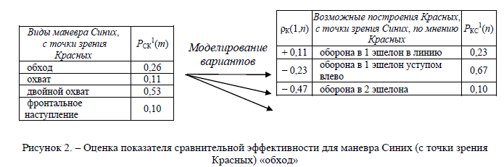
(Figure 2. - Assessment of the indicator of comparative efficiency for the BLU maneuver (in terms of Red) "bypass")
It is interesting to see how the concepts of RGT can be employed in combat. The boolean red and blue games could also be extended into other areas as previously noted, such as geopolitics, which of course we did portray during the cold war as Blue vs. Red. It is interesting to note that in this game of Rulko et al Blue is attacking and Red is defending, again we see the Russian psychology of being on the defense from the West.

Part 2: Reflexive Contemporary Topics:
In the previous section we have delved into the basics of Reflexive Control and Reflexive Game Theory. The research that was done in the 1960s and into the 2000s was conducted by one generation which has given way to a new generation with such authors as Tarashenko and Shemayev extending the work of Lefebvre, and Novikov as well. In the following section we shall be reviewing some recent developments of RC to see how it is becoming extended and in what direction research in this field is leading.
The first researcher to cover is that of Shemayev and the synthesis of RC with Cognitive Mapping.

Reflexive Control becomes Cognitive

The initial ideals regarding the use of cognition was written about by Chotikul in the US in 1986 according to Vasara, RC could be used to exert influence on the adversary’s activities, and it could be applied if the adversary’s cognitive map was thoroughly understood. In this case, objective observations of the situation made by the adversary could be modified without the adversary noticing anything. To achieve the situation described above, the attention should be on psychological aspects and subjective factors characteristic of the adversary. (Chotikul, 1986, p. 79). (Vasara, 2020, 35-6)

From 2007 in Russia Shemayev has written of a synthesis of cognitive modeling and RC.
Volodymyr Shemayev is head of the Department of Economics and Finance of the National Defense Academy of Ukraine, Kyiv. His scientific interests include Reflexive Control, Information Security, Defense Planning and Budgeting, and Ukraine’s Integration to NATO. Shemayev writes:

Another approach to modeling socio-economic systems is cognitive modeling. Cognitive modeling based on fuzzy cognitive maps is considered to be one of the best ways to formalize control processes in social-political and economic systems. Such a mathematical model allows both to analyze the situation in-system and to synthesize a control strategy. (Shemayev, 2007)

Formally, the task of information control can be presented with the following relation:

where
- D(F,W,M) represents the structure of the situatuion;
- G(t) – the set of objectives;
- X(t) – the set of situation conditions;
- U(t) – the set of controls
Then, U*(t) is the rational (optimal) set of controls given by;
U*(t) = Arg opt Φ (t) U(t)∈ U
(Shemayev, 2007)

In order to adequately model the set of controls it is necessary to have a good cognitive model of the target of RC.

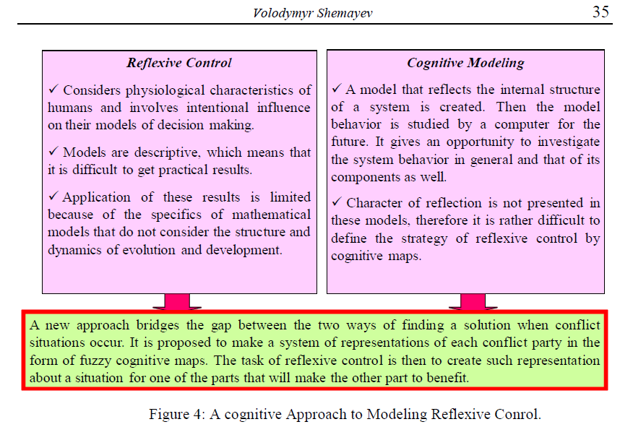
(Shemayev, 2007)

This synthesis of RC and Cognitive Mapping is more like western attempts at behavioral influencing which are covered in a separate chapter. However, it is interesting to compare the procedures of Shemayev compared to what is mentioned by Dr. John Norseen regarding the Inverse, sometimes also referred to as Reverse, and Direct Tasks, sometimes referred to as Forward, of Reflexive Control. Here Shemayev defines the synthesized Forward and Inverse Task:
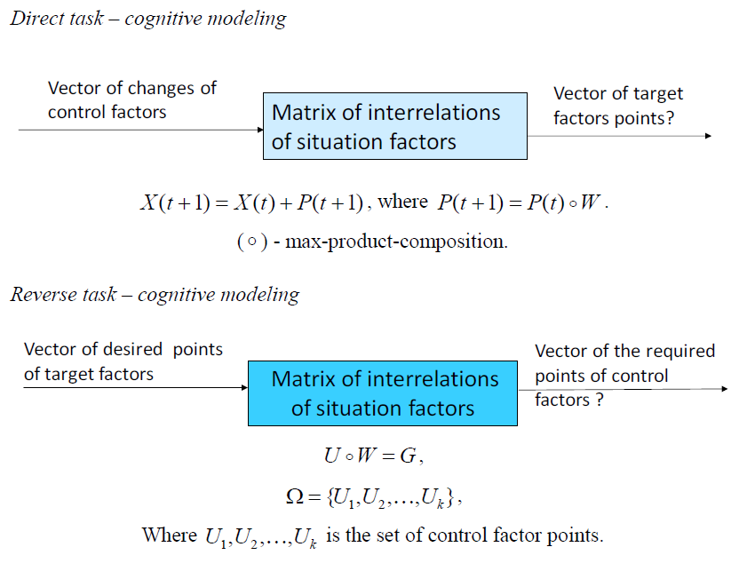

Direct and reverse tasks are used for cognitive analysis and reflexive control of situation development. Shemayev and Taran proposed a new method that bridges the gap between the two approaches to finding a solution when conflict situations occur. The authors propose to make a system of representations of each conflict party in the form of fuzzy cognitive maps. The task of reflexive management is to create such representation about a situation for one of the parts that will make the other part benefit.

Controlling the Mob with Reflexive Control
In other more recent work in RC in Russia is the work of D. Novikov the head the Institute of Control Sciences & Moscow Institute of Physics and Technology of the Russian Academy of Sciences has looked into the issue of mass influencing mobs. Novikov works on the mathematical modeling of mob control in his work. This work can be traced back to earlier work in 1978 by Granovetter and his own work from at least 2008. Mathematical models of Mobs is of two types:

1. Models of Teams- joint adaptive decision-making by groups of people using information aobut uncertain factors, which is not considered by Novikov.

2. Conformity Threshold Collective Behavior (Granovetter 1978)- the decision of a given agent depends on the proportion or number of other agents making a corresponding decision (particularly, mob behavior). Which is considered in the work of Novikov here.

Novikov defines a mob:

“Mob is understood below as an active or aggressive gathering of people, i.e. an active or aggressive group, crowd, etc. In scientific lieterature, mob control has several stable and widespread interpretations.” (Novikov, 2017, 5)

Mobs are viewed as groups of agents, which can also be artificial agents or ‘phantoms’ in RC parlance. The study of agents involves such elements as:

‘Control of agents’ motion (goal achievement, collision avoidance, obstacle avoidance, formation control, etc.). This direction of group control demonstrates intensive development since the early 2000s, embracing two broad fields of research, namely, analytical and simulation (agent-based) models. ...A seperate aspect concerns choosing a set of physical influence measures for a mob (prevention of jams, mass riots, and so on), which also represents a subject of many investigations. (Novikov, 2017, 5)

Novikov gives the basis for Mob stratification:

“Mobs are classified using several bases. This book proceeds from a substantial hypothesis that a mob can be united by a common object of attention (be organized in some sense), while its members-people (agents) may undertake certain actions or not. To put it tentatively, agents can be active (e.g. supporting some decision, participating in mass riots, etc.) or passive. Accordingly, mob control represents a purposeful impact (as a rule, informational influence exerted on a whole mob or separate agents for implementing their desired behavior.[74]. If the goal of control is to optimize the number or proportion of active agents, exactly this index [active,passive] forms a major control efficiency criterion.
As actions of agents and communications among them are both vital for mob anlysis, a mob can be treated as a special case of an active network structure (ANS). Other special cases of ANSs are social groups, online social networks and so on. Some models developed in the book turn out applicable to wider classes of ANSs, not only to mob control problems. In such cases, the term ANS will be used.” pg. 5-6

In short in this terminology a mob is an active network structure or ANS, which are more popularly known as social networks. According to Novikov there are 5 Levels of ANS:

ANS Levels
Level 5: game theory (reflexive) informational conflicts
Level 4: Control Problems
Level 3: informational interactions micro-model of ANS
Level 2: graph structure
Level 1: Macro-model of ANS

In much the same sense as a convolutional neural network as higher levels feed into lower levels. The main issue with ANS analysis and structure is the state of the agents whether they are active or passive.

Model of an ANS:
-each agent chooses between two states:
0- passive
1- active (participation in mob action)

“While making his decision, each agent demonstrates conformity behavior, taking into account the so-called social pressure as the observed or predicted behavior of the environment: if a definite number (or proportion) of his ‘neighbors’ [KNN clustering?] are active, then this agent chooses activity. The minimum number (or proportion) of neighbors that ‘excites’ a given agent is called his threshold. Note there also exist models of anti-confomity behavior and ‘mixture’ of conformity and anti-conformity [26]. “ (Novikov, 2017, 7)

Threshold is the minimum number (or proportion of neighbors that influences a given agent. Equilibrium state of a mob is defined via the distribution function of agents’ thresholds.

“If the relationship between the equilibrium state of a system (a social network, a mob) and the threshold distribution function is known, one can pose threshold control problems, e.e., find an appropriate control action modifying agents’ threshold so that the system reaches a desired equilibrium. “ (Novikov, 2017, 8)

Each agent has an opinion Novikov offers the following iteration to determine threshold behavior.
Model of a mob N = {1,2,….,n) of agents. Agent I in the set of N is characterized by:
1. influence (a certain ‘weight’ of his opinion for agent j)
2. the decision
3. the threshold, defining whether agent I acts under a certain opponent’s action profile.

Formally, define the action x_{i} of agent I as the best response to the existing opponent’s action profile.

“Therefore, given an initial state (the proportion of active agents at step 0), further dynamcs of system (7) and it’s equilibrium states depend on the propoertis of the distribution functions of agent’s thresholds. Hence, a goal-oriented modification of this function can be treated as mob control.

Although the following from Novikov is math intensive, for those interested it is important to understand the basics of how Thresholds are calculated as well as activations. Novikov gives the following equations for his mathematical model of mobs:

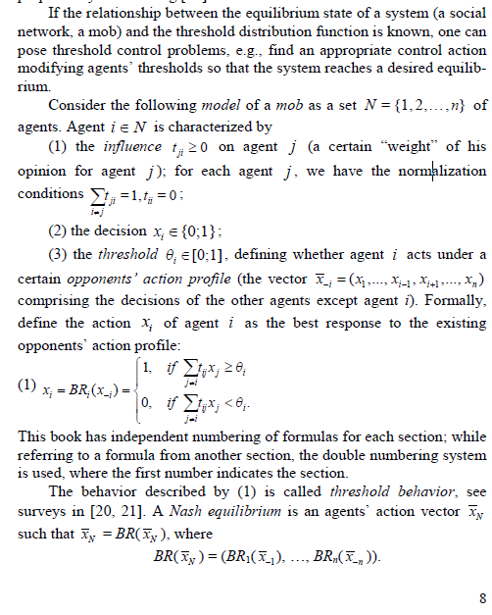

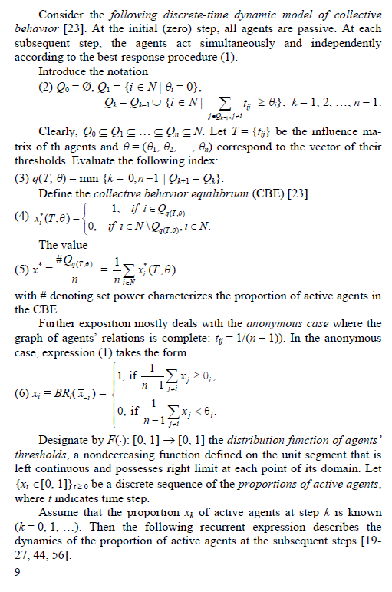
[Insert break down of equations in natural language]

After establishing Collective Behavior Equilibrium (CBE) from above we arrive at mob control which is altering the threshold of agents with a goal-oriented modification [steering, cybernetics].

The Nash equilibrium is calculated as:
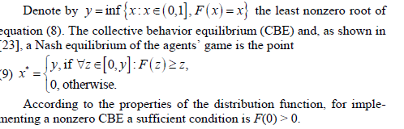
Novikov analyses mob control on two levels a micro and macro scale:

two approaches to the design and analysis of ANSs, namely, macro- and microdescriptions [13, 24]. According to the former approach, the structure of relations in a network is averaged, and agents’ behavior is studied “in the mean.” The latter approach takes into account the structural features of the influence graph of agents and their individual decision-making principles. The first and second approaches are compared using the threshold model of collective behavior with a common relative threshold. (Novikov, 2017, 10)

Threshold Model of Agents Behavior
As mentioned before the threshold of the agents, the influences of neighbors, is a key to the CBE. As mentioned each agent has an opinion which can be influenced. Novikov explains the model:

“The models of agent’s opinions dynamics in ANSs involve a single characteristic of each agent-- his opinion-- and the rest parameters reflect the interaction of agents. The so-called behavioral models of ANSs are richer: in addition to ‘internal’ parameters, the incorporate variables describing agent’s behavior (his decisions). Generally, these decisions depend on the internal parameters of an agent (his opinions, individual characteristics) and, may be, on the opinions and/or actions of other agents (all agents, neighbors or some group of agents). As an example of behavioral models, we choose the threshold model (the general game theoretic modeling approaches to collective threshold behavior were outlined in the publications [Breer 2012]” (Novikov, 2017, 15)

the common relative threshold of the agents is the consensus of the ANS, a common opinion.

Novikov applied his math models in simulation of social networks: Facebook, Twitter and LiveJournal, this work was done in collaboration with A. V. Batov. A social network is a directed graph, which one could use SRI’s A* search to crawl:

“The relations among agents in a real SN can be reflected by a directed graph G. The direction of an edge from one agent (node) to another shows the former’s influence on the latter. The mocromodels address explicitly the influence graph, whereas the macromodels operate it’s macrocharacteristic, i.e., the distribution M(.) of a number of neighbors” (Novikov, 2017, 20)

Novikov provides a simple illustration for the structure of influences on Facebook:

For instance, in Facebook an agent has connections to his friends, which can be interpreted as the influence relations of these friends on the agent. In LiveJournal and Twitter, directed influence relations are agent’s subscriptions for viewing and commenting information posted by other agents. We will believe that all agents influencing a given agent in a network are his neighbors, see expression (1). (Novikov, 2017, 21)

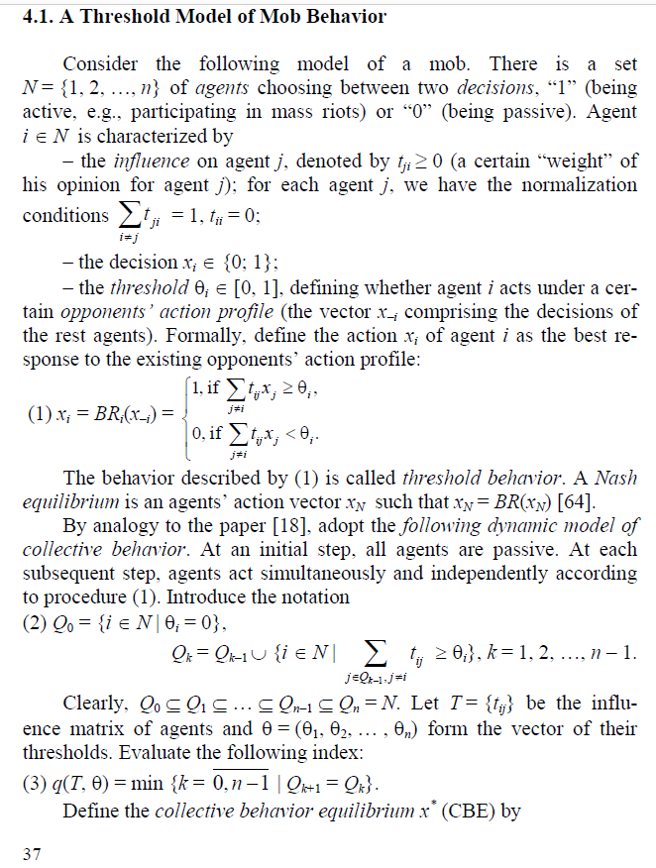

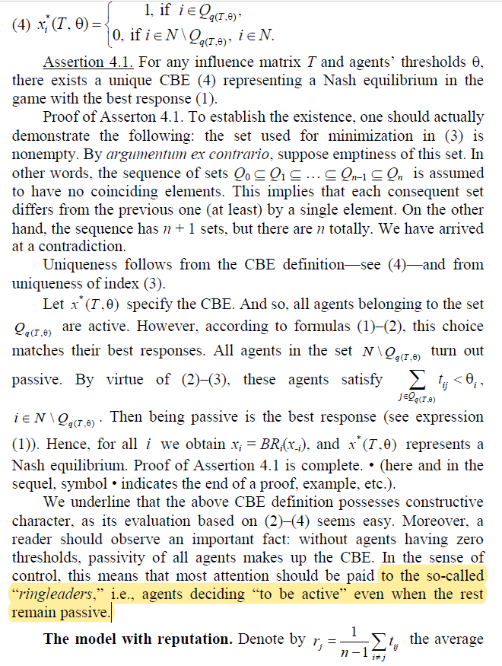

Reputation (Conformity) Control
Another component of mob control involves the reputation of an agent, which is the opinions of other agents of that agent, also their influences upon that agent. This is given mathematically by Novik in the following:

influence of agent j ∈ N on the rest agents. The quantity rj is said to be the relative reputation of agent j (a certain “weight” of his opinion for theother agents). The other agents consider his opinion or actions according to this weight. Within the framework of the model with reputation,
influence can be characterized by the vector r = {ri}i ∈ N. In this model, define the action xi of agent i as the best response to the opponents’ action profile:

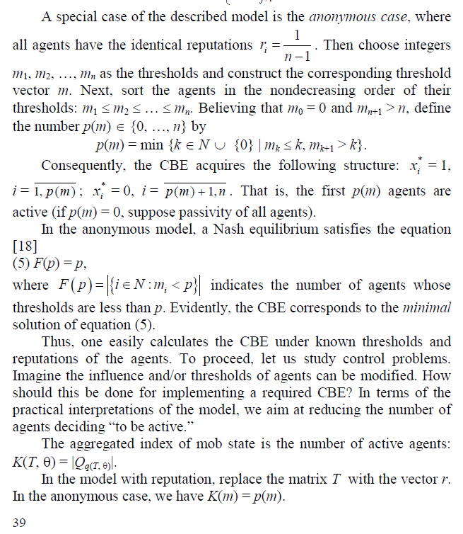
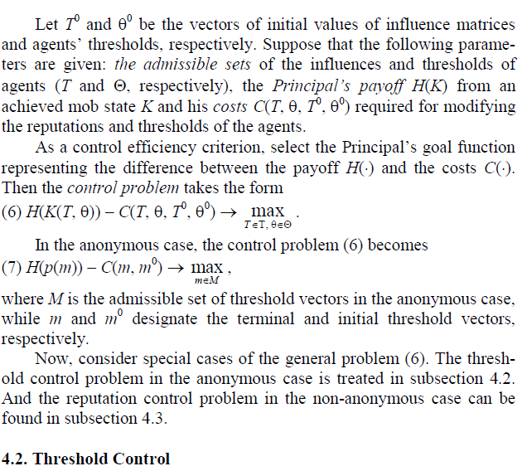

Some examples of the mathematical models considered by Novikov also includes Reflexive Control along with Reflexive Game models of competing Principals usually expressed by a bi-matrix in the considerations. A example of RC in Mob Control is where the Principal influences the beliefs of the agents about their parameters, the beliefs about beliefs. The non-cooperative Principals must control the informational equilibrium, possessing a certain awareness structure the agents choose their actions, here awareness would be the equivalent of an opinion (Novikov, 2017, 49). Novikov argues that the basis of altering awareness or opinions is best conducted through infromation control, or information warfare in military contexts.

...we believe that any result achievable via a real variation of thresholds can be implemented by informational control (an appropriate modification of the agents’ beliefs about their thresholds). And so , information control for thresholds turns out equivalent to threshold control in a common sense. Apparently the former type of control is ‘softer’ than the latter.” One property of ‘good’ informational control concerns its stability [75] when all agents observe the results they actually expected. (Novikov, 2017, 49)

“Among other things, informational control in the ANSs lies in a purposeful impact exerted on the initial opinions of agents, in order to ensure the required values of the final opinions (desired by the control subject)” (Novikov, 2017, 111)

One of the most important elements in information control is stability.

Stability is a substantial requirement for a long-term interaction between the Principal and agents. Indeed, under an unstable information control, the agents just once doubting the truth of Principal’s information have good reason to do it later.” (Novikov, 2017, 49-50)

Stochastic Models of Mob Control
In practice, a possible tool of such control consists in mass media [48, 75] or any other unified (information, motivational and/or institutional [74]) impacts on agents. pg. 50

“For instance, consider the following interpretations of potential control actions: the thresholds of a given proportion of randomly chosen agents are nullified (which matches ‘excitation’) or maximized (which matches ‘immunization,’ ie. complete in-susceptibility to social pressure). Or just believe that each agent can be excited or /and immunized with a given probability. Such transformations of agent’s threshold cause a corresponding variation in the equilibrium state of an active network structure (a social network, a mob).
Another way for managing threshold behavior (not agents’ thresholds) is staff control according to the control types classification introduced in [74]. Staff control implies embedding additional agents with zero and maximum threshold (provokers and immunizers, respectively) in an ANS. In this case, the resulting equilibrium of the ANS depends on the number of embedded agents having an appropriate type.
And finally, there may exist two control authorities (Principals) exerting opposite information impacts on the agents [red vs. blue sub-machines]. This situation of distributed control [43, 74] can be interpreted as informational confrontation [46, 48, 70, 72] between the Principals. Using the analysis results of the control problems for each separate Principal, one can describe their interaction in terms of game theory.” (Novikov, 2017, 51)

Novikov also addresses such things as Provokers in Mobs, Excitation of Whole Mob and Positional Control the main area of concern for this study is the use of Mob Control in Game Theory from normal-form games, to reflexive games to hierarchical games.
What makes Mob Control Game theoretic is the situation with non-cooperative Principals gaming the agents to influence them to achieve the Principals goal state. This is usually expressed in cybersecurity and military simulations as Red vs. Blue. A look at Novikov’s models for Game theoretic considerations is very illuminating in understanding issues in cybersecurity dealing with influencing of masses.

Game-Theoretic Models of Mob Control
Problem description: Consider a set of interconnected agents having mutual influence on their decision-making. Variations in the states of some agents at an initial step accordingly modify the state of other agents. The nature and character of such dynamics depend on the practical interpretation of a corresponding network. Among possible interpretations, we mention the propagation of excitation in biological networks (e.g., neural networks) or in economic networks [49, 54], failure modes (in the general case, structural dynamics models) in information and control systems and complex engineering systems, models of innovation diffusion [controlling scientific consensus], information security models, penetration/infection models, consensus models and others, see an overview in [48]. (Novikov, 2017, 72)

“the control problem of the purposeful ‘excitation’ of a network is to find a set of agents for applying an initial control action so that the network reaches a required state. This abstract statement covers informational control in social networks [8, 48], collective threshold behavior control, etc. (Novikov, 2017, 72)

“The goal function of a control subject (Principal is the difference between the income and the costs. For the Principal, the centralized control problem lies in choosing a set of initially excited agents to maximize the goal function…” (Novikov, 2017, 74)

“Using relationship (4) between the final opinion of the agents and the control actions, one can suggest a game-theoretic interaction model fo the agents performing these actions. To this end, it is necessary to define their goal functions. Suppose that the goal functions of the first and second agents… are calculated as the difference between their ‘income’ that depends on the final opinion of the agents and the control costs. “ (Novikov, 2017, 112)

“the aggregate… composed of the goal functions and feasible action sets of the two agents specifies the family of games. The distinctions among these games are induced by the awareness structure of the players and the sequence of functioning [74].” (Novikov, 2017, 112)
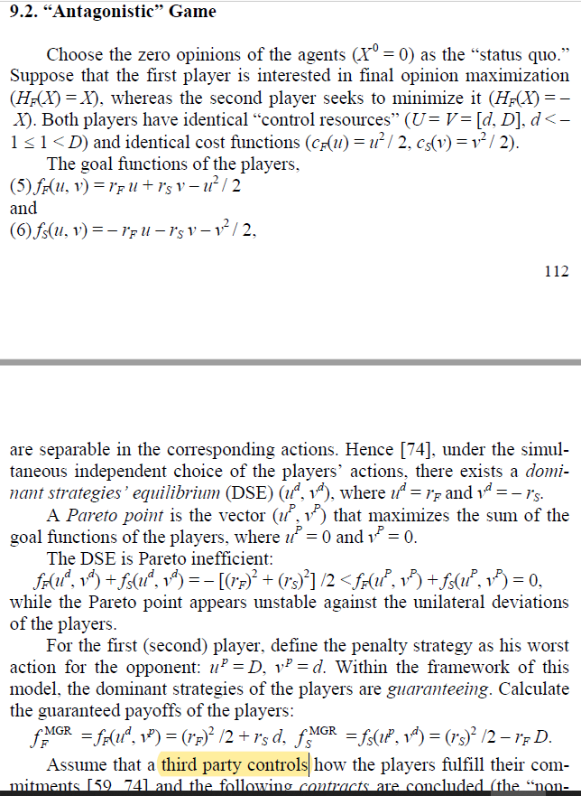
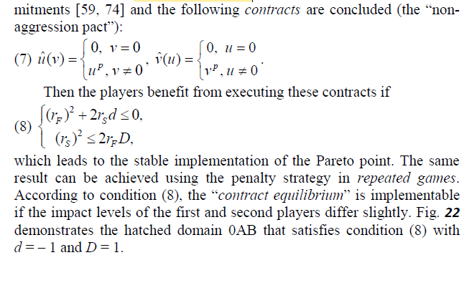
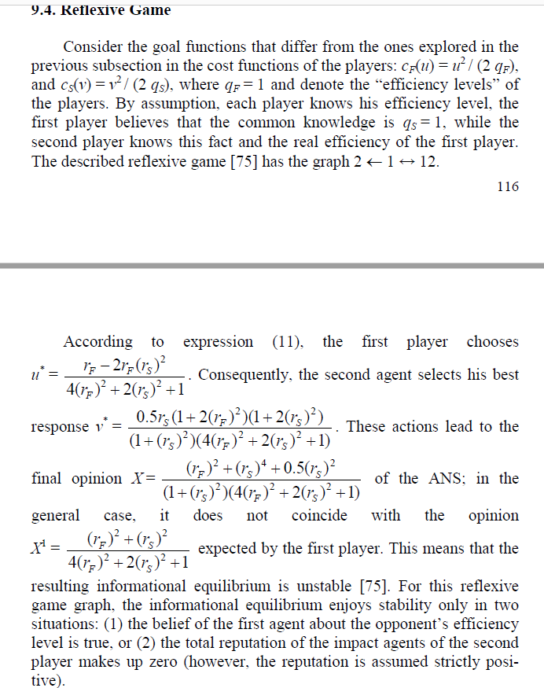

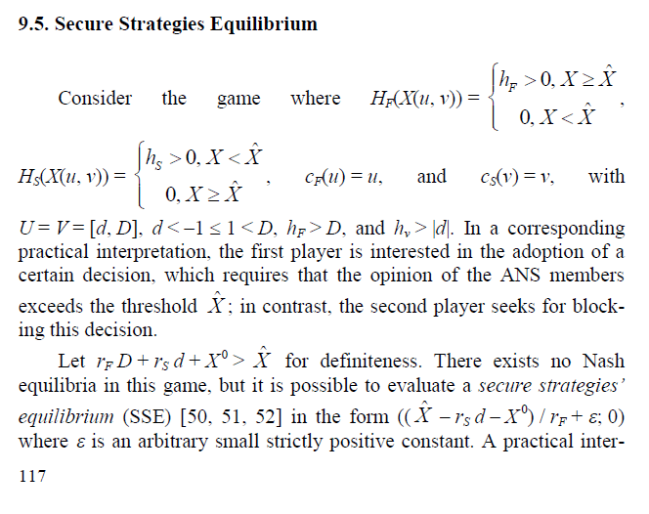

pretation of the SSE lies in the following. The first player ensures the adoption of the required decision, and the second player (even choosing the maximum possible absolute values of the actions) is unable to modify the result.
In this section, we have analyzed a series of specific examples illustrating the applicability of game theory to the description of informational confrontation in ANSs, both in terms of the process and result. Despite its simplicity, the stated model shows the diversity of possible gametheoretic formulations (dominant strategies’ equilibrium, Nash equilibrium, “contract equilibrium,” Stackelberg hierarchical games and hierarchical games of the type Г1, reflexive games, secure strategies’ equilibrium).
Generally speaking, any specific model of informational confrontation should be developed taking into account, first, the features of an associated practical problem and, second, the identifiability of a
modeled system (i.e., ANS parameters, the admissible actions of the players, as well as their preferences and awareness). Note that the game-theoretic models of informational confrontation over ANSs have several applications, namely, information security in telecommunication networks, counteraction to the destructive informational impacts on the social groups of different scale, prevention of their
massive illegal actions, and others.
As for the promising directions of further investigations, we mention the design and study of the game-theoretic models of informational confrontation in ANSs under the following conditions:
– the sequential choice of the players’ actions under the observed dynamics of the ANS state (the “defense-attack” games with the description of opinion dynamics (the distribution of information an epidemic or viruses [memes] within an ANS));
– the repeated choice of the players’ actions under incomplete information on the actions of the opponents and the ANS state. (Novikov, 2017, 117-8)

It is important to note that there is no Nash Equilibrium in a SSE game, which is exemplified in a war platform such as Lockheed-Martin’s evolutionary games model of Lockheed’s Senglaub which also uses SSE.

The issue of superstructuring games, or hierarchical games, is addressed by Novikov as well:

10.4 Hierarchical Game
“In mob control problems, the players (principals) often make decisions sequentially, Here the essential factors are the awareness of each player at the moment of decision-making and the admissible strategy sets of the players. A certain hierachical game can be ‘superstructured’ over each normal-form game [74]. Moreover, it is necessary to discriminate between two settings as followed:

1. one of the Principals chooses his strategy and then the other does so, being aware of the opponent’s choice. After that, an informational impact is exerted on the agents. As a result, the distribution functions of the agent’s thresholds takes form…
2. One of the Principals chooses his strategy and exerts his informational impact on the agents. After that, the other Principal chooses his strategy and exerts his informational impact on the agents, being aware fo the opponent’s choice. (Novikov, 2017, 131)

10.5 Reflexive Game
“it is also possible to ‘superstruct’ reflexive games [75] over a normal-form game where the players possess nontrivial mutual awareness about some essential parameters. (Novikov, 2017, 131)

Novikov’s work on Mob Control mathematical modeling gives us valuable insights into influence campaigns conducted on a daily basis on such social networks as Facebook, Twitter, and others. The need for mass education on influence machines is one that should be addressed by regulators at all levels of civil oversight with appropriate international laws applied to such use of mob control and cyber influencing. It is not hard to imagine why a military power might want to be able to control mobs in enemy areas which necessarily raises issues of the Geneva Conventions and other bans on prohibited weapons, making their use a war crime, but of course proving such a case in law may be a complete impossibility which would leave competing military powers to develop their own offensive and defensive influence machines.

I, Robot Reflexion:

Another contemporary scientist working in the field of Reflexive Control is that of Serge Tarashenko. A younger researcher, who has written articles for the Journal of Reflexive Control as well as his own independently published results of applying RC in Games, applying Emotions to Agents, and socializing mixed groups of Robots and Humans for the purposes of steering the Humans with the Robots.
Earlier we encountered Tarashenko’s work in terms of Alliance/Conflict groups or otherwise known as Red vs. Blue. In this section we will be mainly going over his research regarding using Robots to train Humans using Reflexive Control. Tarashenko introduces the subject of Robots into Reflexive Game Theory in 2010.

Robots – the goal of the robots in the mixed groups of humans and robots is to refrain human subjects from choosing risky actions. [inverted can be used to create terrorists, etc]

In a nod to Asimov, Tarashenko argues that the Robots should always observe the 3 Laws of Robotics. Introducing a certain assumption of moral responsibility behind the Robots actions, of course we know in a military or weaponized context these safeguards would be contradictory to using Robot agents when the goal of the Robot is to use force to stop an adversary, and hence not included in any war application.

Review, pg. 19: Basic Control Schema of a Robotic Agent
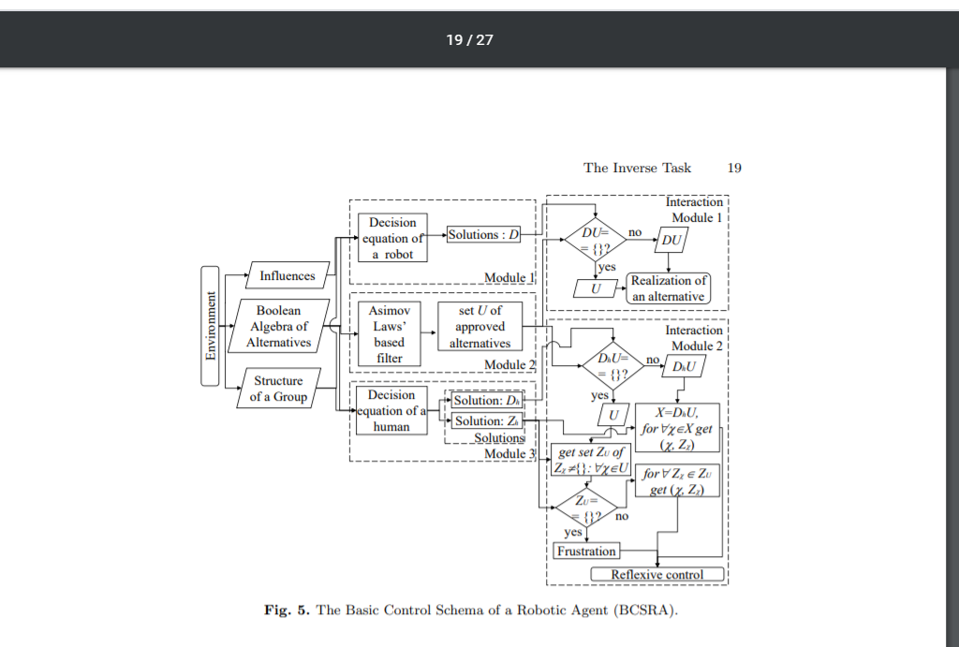
(Tarashenko, 2010)

Tarashenko explains the flow diagram, where you take in a set of alternatives for the controlled subject:

The output of the Module 1 is set D of alternatives, which robot has to choose under the given joint influences. In the Interaction Module 1, the conjunction of sets D and U is performed: D ∩ U = DU. If set DU is not empty set, this means that there are aproved alternatives among the alternatives that robot should choose in accordance with the joint influences. Therefore, robot can implement any alternative from the set DU. If set DU is empty, this means that under given joint influences robot cannot choose any approved alternative, therefore robot will choose an alternative from set U. This is how the Interaction Module 1 works.
The output of the Module 3 contains sets Dh and Zh. The goal of the robot is to refrain human subjects from choosing risky alternative. This can be done by convincing human subjects to choose alternatives from the set U. First, we check whether Dh contains any approved alternative. We do so by performing conjunction of sets Dh and U: Dh ∩ U = DhU. If set DhU is not empty, then it means that it is possible to make a human subject to choose some non-risky alternative. Therefore, we should choose the corresponding reflexive control strategy from the set Zh. However, if set DhU is empty, we have to find the reflexive control strategy that will make human subject to select approved alternative from set U. For this purpose, we construct set ZU by including all the joint influences Zχ for approved alternatives: Zχ ∈ ZU ⇔ χ ∈ U. Next we check whether set ZU is empty. If set ZU is empty this means it is impossible to convince a human subject to choose non-risky alternative. Therefore, the only option of reflexive control in this case is to put this subject into frustration state. However, if set ZU is not empty, this means that there exist at least one reflexive control strategy that results in selection of alternative from the set of the approved (non-risky) ones (Tarashenko, 2010)

In computing and robotics one method suggested to increase the robot or artificial agents ability to work in an environment is to add emotions. Tarashenko has proposed the use of the Pleasure-Arouseal-Dominance (PAD) model to robotics. PAD is traced back to Mehrabian and Russell 1974 to assess environmental perception, experience and psychological responses. The three dimensions can be linked to the current ABC Model of Attitudes: pleasure, arousal and dominance can be respectively related to affective, cognitive and conative responses, ie. Affect (feeling), Cognition (thinking) and Behavior (acting) (ABC). (Mehrabian & Russell, 2014). Previous to this Kelly in 1955 came up with the Theory of Bipolar Constructs of Good (+) / Bad (-). The propensity of turning toward good and bad is estimated by V. Lefebvre that the positive pole is chosen by 61.8% of subjects and the negative pole by 38.2%. Later in 1957 Osgood proposed the semantic differential approach which characterizes a subjects personality as Evaluation, Activity, Potency. Which Mehrabian & Russell proposed the PAD on. In Neuromarketing, the business implementation of neurowarfare, uses the PAD model in Self-Assessment Manikin (SAM) Tests, emotional responses of consumers can be recorded through the SAM scale. This is a non-verbal pictorial assessment technique applicable for direct measurement of P,AD associated with a persons affective reaction to a wide variety of stimuli.
In this study of Tarashenko he uses the PAD model along with Reflexive Game Theory (RGT) to emotionally color the interactions between humans and robots. The emotional research based on PAD model is transparent and clear. The models of robots exhibiting human like emotional behavior using only PAD has been successfully illustrated in recent book by Nishida et al. [23]. Nishida, T., Jain, C. L., and Faucher, C.: Modelling Machine Emotions for Realizing Intelligence. Foundations and Application. Springer-Verlag Berlin Heidelberg (2010). The ideal of mixing emotions with AI agents, Affective Computing (see Nashida), can be traced back to earlier work in the Soviet Union with Russian Pospolev’s Psychonics theory of computation in the 1960s. The basics of PAD begin with a 3 axis layout, one axis for P, A, D.

By definition, PAD model is spanned by three dimensions. The value of each component continuously ranges from -1 to 1. The notation in the PAD model space presented in Fig. 1 are as follows:
1) pair +P vs -P corresponds to Pleasure (positive pole: value 1) vs Displeasure (negative pole: value -1);

2) pair +A vs -A corresponds to Arousal (positive pole: value 1) vs Non-arousal
(negative pole: value -1); and

3) pair +D vs -D corresponds to Dominance (positive pole: value 1) vs Submissiveness (negative pole: value -1).

According to Mehrabian [22], “pleasure vs displeasure" distinguishes the positive vs negative emotional states, “arousal vs non-arousal" refers to combination of physical activity and mental alertness, and “dominance vs submissiveness" is denied in terms of control vs lack of control [22]. (Tarashenko, 2010b)

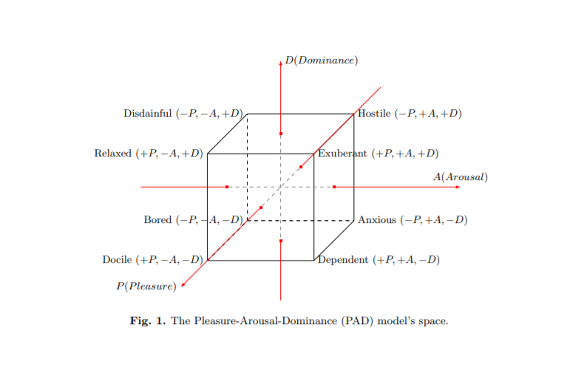

Among eight basic states (hermetry 8), there are three special emotional states:
Docile (+P,-A,-D) ≡ {1, 0, 0}),
Anxious (−P, +A, −D) ≡ {0, 1, 0}) and
Disdainful (−P, −A, +D) ≡ {0, 0, 1}).

These three states are the basis of the 3d binary space. Thus, any other five emotional states can be considered as disjunction (notations OR/∪/+) of these three basis vectors (emotional states). For example, emotional state Dependent (+P, +A, −D) is disjunction of basis states Docile (+P, −A, −D) and Anxious (−P, +A, −D): Docile OR Anxious = (+P, −A, −D) ∪ (−P, +A, −D) = {1, 0, 0} ∪ {0, 1, 0} = {1, 1, 0} = (+P, +A, −D) = Dependent. (Tarashenko, 2010b, 3-4)

The complete set of emotional states represented as binary vectors is
Docile (+P, −A, −D) is coded as {1, 0, 0};
Anxious (−P, +A, −D) is coded as {0, 1, 0};
Disdainful (−P, −A, +D) is coded as {0, 0, 1};
Hostile (−P, +A, +D) is coded as {0, 1, 1};
Dependent (+P, +A, −D) is coded as {1,1,0};
Relaxed (+P, −A, +D) is coded as {1, 0, 1};
Exuberant (+P, +A, +D) is coded as {1, 1, 1};
Bored (−P, −A, −D) is coded as {0, 0, 0}.

Tarashenko proposes through this model to alter emotions of the human subjects:

we note that PAD model provides description of how the emotional states of humans can be modeled, meaning that a certain emotional state of a particular person can be changed to the desired one. Furthermore, it is straightforward to see that the coding of the PAD emotional states and alternatives of Boolean algebra are identical. (Tarashenko, 2010b, 7)
often people directly express their emotions in actions in such cases a particular emotional state of a subject can be considered as the influence he is making on other subjects. (Tarashenko, 2010b,7)

Using the PAD one can alter the emotions of a group:

Alliance:
Example 1. Subjects a and b are in alliance relationship. Subject a makes influence Dependent {1, 1, 0}. Subject b makes influence Relaxed {1, 0, 1}. Their resultant influence will be (a · b) = {1, 1, 0}{1, 0, 1} = {1, 0, 0} or Docile. Consequently, the influence of the group, including subjects in alliance with each other, on a given subject is considered as conjunction (defining compromise of all the subjects in alliance) of the influences of all the subjects’ influences.

Conflict:
Example 2. Subjects a and b are in conflict relationship. Subject a makes influence Docile {1, 0, 0}. Subject b makes influence Disdainful {0, 0, 1}. Their resultant influence will be (a + b) = {1, 0, 0}{0, 0, 1} = {1, 0, 1} or Relaxed. Therefore, the influence of the group, including subjects in conflict with each other, on a given subject is considered as disjunction (defining overall influence since compromise is impossible) of the influences of all the subjects’ influences

RC is an attack on the mind of a subject, usually cognitively, through using words to alter perception. However, with PAD-RGT one can have Reflexive Emotional Control: emotional states can appear to be the subject for the reflexive control, emotions being large impactors on motivation and what actions are chosen by a given controlled subject.

“…we have not only illustrated how to apply RGT to the control of subject’s emotions, but uncovered the entire cascade of human reflexion as a sequence of subconscious reflexion, which allows to trace emotional reflection of each reflexive image. This provides us with unique ability to unfold the sophisticated structure of reflexive decision making process, involving emotions.” (Tarashenko, 2010b,10).

It is known that the Amygdala is the manager of emotions, it is also the seat of Fast Reflexion as brought forward by Lefebvre, which is unconscious automatic processing. “According to Ekman [7], emotions should be regarded as highly automatics processing algorithms responsible for our everyday life survival. Being entire unconscious (automatic) regulators of the human body’s physiology, emotions bring the instantenous solutions of how to act in front of rapidly approaching possible threat. This instantenous activity is possible due to unconscious processing algorithms, which have been characterized by Lewicki et al. [20, 21] as highly non-linear by nature and extremely fast by performance” (Tarashenko, 2010b, 11)

Therefore, emotions are fast processors of the information coming apart from environment. Usually, the emotions are characterized by some physiological patterns of body activity on the one hand, and external expression by face mimic or gestures on the other hand. From this point of view, the fact that the reproduction by the self of physical part of emotional pattern, i.e., just making an angry face can elicit the anger as emotional state itself [9, 19], is completely scientifically unexpected phenomenon. (Tarashenko, 2010b, 11). It is important to understand here that what is being said that just see a sad face can make one sad, or seeing an intimidating face puts one in a fear defense response. In this sense one can attempt Emotional RC on another just by frowning at them and change their emotional state, as well one could also control their muscles to put them into a frown, and the corollary sad emotion will be triggered as well. This kinesthetic trigger is able apply to affect a wide variety of motor actions, causing some emotional states to emerge “therefore, it is possible to control human emotions not directly, but making people perform particular actions.” (Tarashenko, 2010b, 11)

One can alter another’s image by simply mimick the emotions you want them to experience in your outward expression, which becomes important when modeling the self and others in the steps of RC:

“From this point of view, the self-mimicking is reflexive process. Thus, it is possible to elicit and understand the emotions of others by reflexion. Ekman et al. [9](p. 1210) suggested that this is possible due to “... direct connections between motor cortex and hypothalamus that translates between emotion-prototypic expression in the face and the emotion-specific patterning in the autonomic nervous system”. (Tarashenko, 2010b, 11)

From the PAD model applied to AI Agents we now have a rough approximation, as statistics can only best provide at the most, of human emotions in AI algorithms, and developed for the purpose of more efficient Reflexive Control.

Robots in Networks of Humans

Now having understood how robots can at least now mimic human emotions it is good to understand how they are to fit into the Red. vs. Blue architecture of Reflexive Game Theory. Tarashenko in 2015 wrote a paper addressing the issue of Network Acitivity of Robots including the communications protocols he envisioned for group collaboration in Alliance and Conflict teams of mixed groups of Robots and Humans.
First we need to have a better understanding of the term ‘reflexia’ and how it specifically is used:

The notion of reflexia in the psychological context was first introduced by Lefebvre in late 60s [1], [2], [3]. Reflexia means projection of the external world on one’s mental state. More specifically, if a human being stands in the field of barley he/she can imagine ones self standing in the field of barley from the 3rd person’s perspective. Thus, preserving the egocentric point of view humans are capable of imagining their own allocentric representation. 1 Therefore, the gist of reflexia is an ability to imagine self perception in the allocentric reference frame (external2 point of view) being operating in the one’s egocentric reference frame. Reflexia is an ability to penetrate into the deeper layers of one’s psychological state. An abstract example of penetration into the deeper layers is when subject a can imagine another person (subject b), who is imagining subject a, the world around and himself imagining it

There are two theoretical explanations for Reflexia brought up by Tarashenko aside from those originally proposed by Lefebvre:

A. “Mirror neuron system: The key concept of the Mirror Neuron System discovered by Rizzolatti and his colleagues [4], [5] is that there are neurons in primate brain that activate in both cases when primate is doing a particular action itself or observe someone else doing the same action. Therefore mirror neuron system translates external state of another agent into the internal state of the current agent. Therefore primates can repeat the observed action. This functionality is very close to the notion of reflexia.“ (Tarashenko, 2015, 1)

B. Perception of Emotions – proposed based on facial recognition and emotional responses of face

The question that the paper addresses mainly is that of how to synch groups of agents, given their Alliance/Conflict value, so that they can coordinate actions in influencing humans to choose the positive pole of the Principal. Tarashenko employs Frequency Domain Multiplexing, that is each robot communicationss with each other via specific frequency based on alliance/conflict groups, which is also reminiscent of Kernbach’s mapping of entangled objects, each has a unique frequency. In Tarashenko’s prposal each robot has a uniqueID and frequency. Spiking is a part of such a communications network, you might imagine a spike wave crossing over a group, inhibitory/excitatory (active/passive) pulses are sent through the network, each series of pulses starts 1ms after the system onset. Pulsations are based on Resonate and Fire linear neural model proposed by Izhikevich. Resonate and Fire Neurons

Tarashenko explains how this works:

We present the sample dynamics of two resonate-and-fire neurons, described by system (16), with different eigenfrequencies ω1 = π 3/2 and ω2 = π 4/3 in Fig. 4. It is illustrated that neurons with eigen-frequency ω1 spikes for the series of pulses with the same frequency and does not respond to the series of pulses with frequency ω2. The same is true for the second neurons regarding shift in roles of frequencies ω1 and ω2. Thus, we have described the mechanism of frequency selectivity. This can be used to enable multiple neurons to talk to each other via the same medium by means of Frequency Domain Multiplexing. However, the linear model has other important properties. The inhibitory pulses can also make resonate-and-fire neurons to spike, if the inhibitory pulses ar applied with the eigenfrequency of the neuron (Fig. 5). However, it is not the final feature of this model. It is
possible to make the neuron fire with series of pulses of different magnitudes. For example, let the magnitudes of the first, second and third pulses are 0.1, 0.4 and 0.6, respectively (Fig. 6). The same result will occur for the inhibitory pulses (Fig. 7). Since the neurons are selective to a certian frequency, it is possible to transfer signals of several frequencies through the same communication channel. (Tarashenko, 2015, 4)

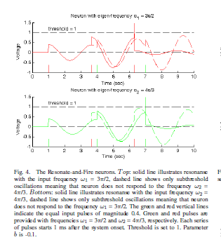

Information Coding- each autonomous unit has several resonators tuned to particular frequency.
- each unit corresponds to a resonators
- resonators = units (each unit has unique frequency)
- units send pulses with alliance or conflict values, if the series pulses contains the excitatory impulses, the sender/receiver = alliance, else in conflict message = {0.4, 0.4, 0.4} if an sender self frequency (resonator unique freq)

to send message to other agent:
1. sender transmits ID-code
-neuron spikes units b,c of which a is net or get member, and b,c understand a wants to transmit msg.
-after short delay 0.5sec after spike unit a sends a code to other frequency.

Options Polarity (see Lefebvre Algebra. Of Conscience.)
alliance = + polarity {0.4, 0.4, 0.4}
conflict = - polarity {-0.4, -0.4, -0.4}
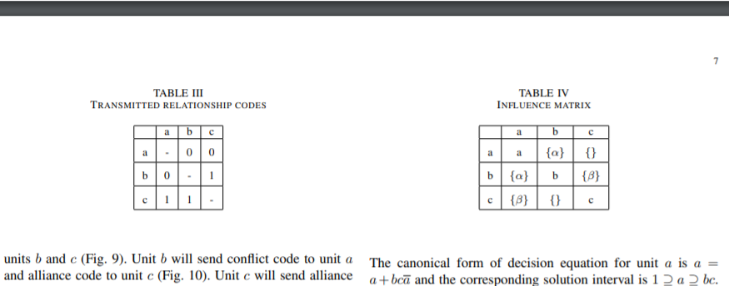
alliance relationship results if both units consense on relationship codes:

Influences: the second part of the algorithm then calculates influence matrix of each node in groups, in reflexive control, the influences are applied to a subject or target to inverse or feed forward way (backward and forward propogation).

The only difference is that instead of the alliance or conflict unit transmission some code associated with a particular alternative.
- units can make mutual influences in order to achieve a particular goal in a cooperative behavior task.
- once each unit receives information about the structure of the group and the mutual influences, each autonomous unit can apply algorithms of RGT inference. Thus, each unit can make both it’s own choice and also predict the possible choices of other members of the group.

Serge Tarashenko also goes into Decision Making with his analysis and modeling of RGT in Multistage Decision Processes.

The Reflexive Game Theory (RGT) [1, 2] allows to predict choices of subjects in the group. To do so, the information about a group structure and mutual influences between subjects is needed. Formulation and development of RGT was possible due to fundamental psychological research in the field of reflexion, which had been conducted by Vladimir Lefebvre [3].
The group structure means the set of pair-wise relationships between subjects in the group. These relationships can be either of alliance or conflict type. The mutual influences are formulated in terms of elements of Boolean algebra, which is built upon the set of universal actions. The elements of Boolean algebra represent all possible choices. The mutual influences are presented in the form of Influence matrix. (Tarashenko, 2012)

RGT Inference Steps (Single Session)
- formalize choices in terms of elements of Boolean Algebra of alternatives
- presentation of a group in the form of a fully connected graph of alliance and conflict
- if graph is decomposable: then it is polynomial: alliance is a conjunction operation; conflict is disjunctive operation
- Diagonal Form transformation
- Run the decision equations
- input influence values into the decision equations for each subjects

each process of making a decision in a group is a ‘session’ (Tarashenko, 2012)

This study is dedicated to the matter of setting mutual influences in a group by means of reflexive control [4]. The influences, which subjects make on each other, could be considered as a result of a decision making session previous to ultimate decision making (final session). We will call the influences, obtained as a result of a previous session(s), a set-up influences. The set-up influences are intermediate result of the overall decision making process. The term set-up influences is related to the influences, which are used during the final session, only. (Tarashenko, 2012)

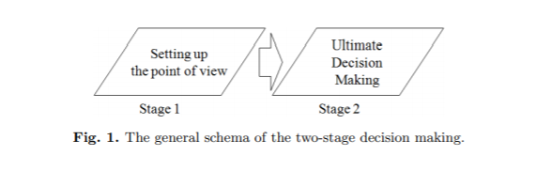

“...using the 2 stage decision making it is possible to make one’s opponents choose one’s point of view.” (Tarashenko, 2012, 5). How does one get this done, in this study Tarashenko offers up the exlusion or changing the structure of a group by node removal from the connected graph of a opposing viewpoint to the Principal seeking to push through their agenda in a decision making group. In decision making there are consecutive decisions, decisions regarding a single parameter, a secondary process is ‘parallel decision’ with distinct parameters.

A Game of Violence, Exclusion and Degradation
When you play dodge ball and you are dodging, ducking, diving and dodging, you are play a game that seeks to knock you out of the arena. Well RC is no different. In the following section I review Tarashenko’s two examples of changing structure to your benefit, first excluding a member from a decision from Tarashenko 2012 and second, Reflexive Emotional Control to alter the opinions of a member of a group from Tarashenko 2010.

Excluding a Member from a Decision:

A Model of a multi-stage decision making: set-up parameters of the final session

Now we consider the two-stage model in more details. In the considered example, during the preliminary session only the decision regarding the influences has been under consideration. In general case, however, before the final session has begun, there can be made decisions regarding any parameters of the final session. Such parameters include but are not limit to:
1) group structure (number of subjects and relationships between subjects in a group);
2) points of view;
3) decision to start a final session (a time when the final session should start), etc.
We call the decision regarding a single parameter to be consecutive decision, and decisions regarding distinct parameters to be parallel decisions. Therefore, during the first stage (before the final session) it is possible to make multiple decisions regarding various parameters of the final session. This decisions could be both parallel and consecutive ones. We call such model of decision making to be a multi-stage process of decision making (Fig.3).

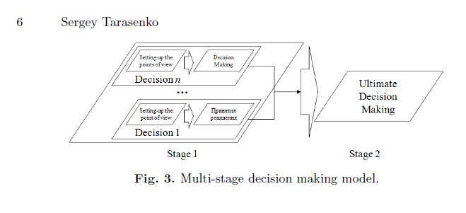
4 Modeling multi-stage decision making processes with RGT
Next we consider realization of multi-stage decision making with RGT. Example 2: Change a group structure. Considering the subject from Example 1, we analyze the case when director wants to exclude the 3rd advisor from the group, which will make the final decision. In such a case, there is a single action 1 to exclude subject d from the group. Then Boolean algebra of alternatives includes only two elements: 1 and 0. Furthermore, it is enough that director just raise a question to exclude subject d from a group and make influence 1 on each subject: if = 1, then a = 1, b = 1 and d = 1 (Table 2). Thus the decision to exclude subject d from the group would be made automatically (Fig.4).

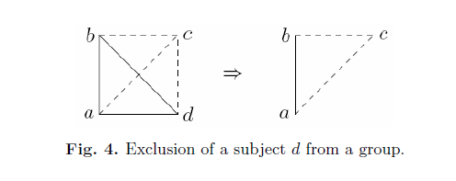
Example 3: Realization of a multi-stage decision making. Let the first decision discussed during the rst stage is a decision regarding influences (points of view). The next decision was about exclusion of a subject d from the group. Thus, during the first step the formation (setting-up) of points of view has been implemented, then the structure of a group was changed. Therefore the group, which should make a nal decision is described by polynomial ab+c. The decision equations and their solutions are presented in Table 4. The overall multi-stage decision making process is presented in Fig.5.

We consider that the point of view cannot change without preliminary session regarding the parameter. Therefore we assume that the points of view do not change after the change of group structure.

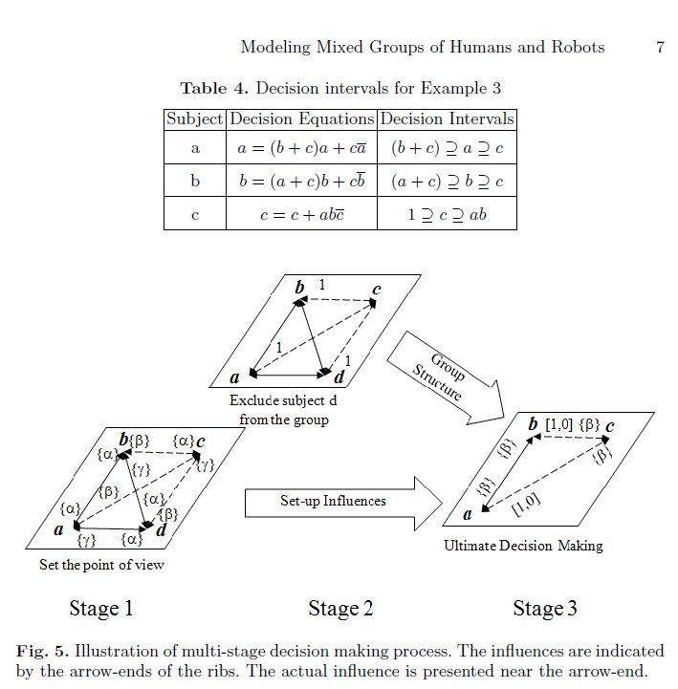

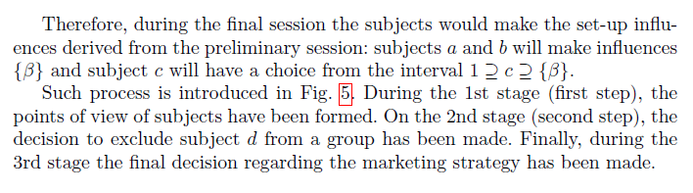

Second, Reflexive Emotional Control:
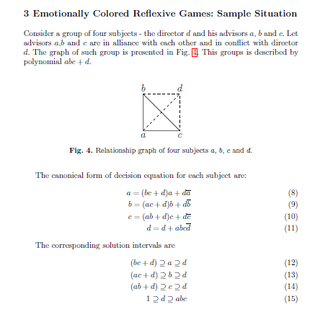

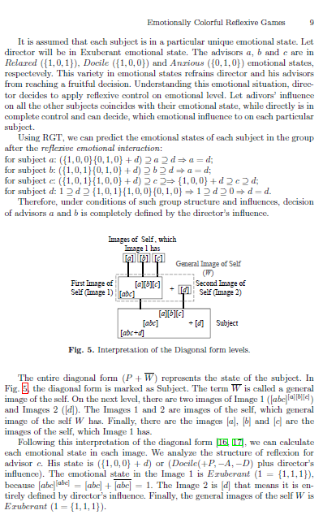

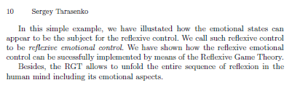

Bibliography:

-Brannon, N., Conrad, G., Draelos, T., Seiffertt, J., Wunsch, D. Zhang, P. Coordinated (2007) ‘Machine Learning and Decision Support for Situation Awareness: SANDIA REPORT SAND2007-6058 September 2007

- Chotikul, D. (1986) ‘The Soviet Theory of Reflexive Control in Historical and Psychocultural Perspective: A Preliminary Study’
Naval Postgraduate School, Department of the Navy Postgraduate School
Prepared for C3CM Kirtland Air Force Base, NM 87117

- Kiryushinm A.N., (2013) Information confrontation: the problem of terminological insufficiency
https://www.catu.su/analytics/439-informacionnoe-protivoborstvo-problema-terminologicheskoj-nedostatochnosti

- Lefebvre, V., & Adams-Webber, J. (2002). Function of Fast Reflexion in Bipolar choice.

- Nikitaev, V. (2011) ‘Foresight as reflexive control’ (Russian) Journal of Reflexive Control and Processes Vol. 11 http://www.intelros.ru/pdf/rpu/1-2_2011/9.pdf

-Novikov, D. A., Chkhartishvili, A. (2015) ‘MODELS OF REFLEXIVE GAMES IN CONTROL PROBLEMS OF ECOLOGICAL-ECONOMIC SYSTEMS’ In Game-Theoretic Models in Mathematical Ecology / Edi-tors: V. Mazalov, D. Novikov, G. Ougolnitsky, L. Petrosyan. – New York: Nova Science Publishers, 2015. – P. 167 – 174. ISBN 978-1-63483-489-6. (Trapeznikov Institute of Control Sciences, Russian Academy of Sciences, Moscow, Russia)

- Novikov, D.A., Breer, V., Rogatkin, A. (2017) ‘Mob Control: Models of Threshold Collective Behavior’ Russian Academy of Sciences Institute of Control Sciences & Moscow Institue of Physics and Technology https://www.researchgate.net/publication/311911469_Mob_Control_Models_of_Threshold_Collective_Behavior

- Rulko, E., Buloychik, V. Gertsev, A. (2017) ‘Application of a Simulation System for Optimizing Solutions Based on the Elements of the Theory of Reflexive Control’ in COLLECTION OF SCIENTIFIC ARTICLES OF THE MILITARY ACADEMY OF THE REPUBLIC OF BELARUS 32'2017, pg. 153

- Schumann, A. (2018) ‘Reflexive Games in Management’ in Studia Humana Volume 7:1 (2018), pp. 44—52 DOI: 10.2478/sh-2018-0004
- Schumann, A. (2014) ‘Payoff Cellular Automata and Reflexive Games’ in Journal of Cellular Automata January 2014

- Shemayev, V. (2017) REFLEXIVE MODELING BUSINESS PARTNER SELECTION IN SUPPLY CHAIN

- Shemayev, V. (2007) Cognitive Approach to Modeling Refelxive Control in Socio-Economic Systems in Information and Security Vol. 22, 2007, 28-37

- Tarashenko, S. (2010a) The Inverse Task of the Reflexive Game Theory: Theoretical Matters, Practical Applications and Relationship with Other Issues https://www.researchgate.net/publication/47797138_The_Inverse_Task_of_the_Reflexive_Game_Theory_Theoretical_Matters_Practical_Applications_and_Relationship_with_Other_Issues

- Tarashenko, S. (2010b) Emotionally Colorful Reflexive Games
Deparment of Intelligence Science and Technology, Graduate School of Informatics Kyoto University, Yoshida honmachi, Kyoto 606-8501, Japan infra.core@gmail.com (2010) https://www.researchgate.net/publication/48178099_Emotionally_Colorful_Reflexive_Games
- Tarashenko, S. (2016) Socializing Autonomous Units with the Reflexive Game Theory and Resonate-and-Fire Neurons https://www.researchgate.net/publication/303370445_Socializing_Autonomous_Units_with_the_Reflexive_Game_Theory_and_Resonate-and-Fire_Neurons
-Tarashenko, S. (2010) Modeling multistage decision processes with Reflexive Game Theory
https://arxiv.org/abs/1203.2315

- Vasara, A. (2020) Theory of Reflexive Control: Origins, Evolution and Application in the Framework of Contemporary Russian Military Strategy Finnish Defence Studies #22

